# **Three basic responsive design Principles**

# 1.Fluid grids and layouts

To allow content to easlilt adapt to te current viewport width, used to browse the website. The accent here is to exclusively use percentages and relative rem/em nits instead of px for all layout-related lengths.

# 2.Flexible/Responsive Images

Images behve differently than text content, and do not automatically scale to fit their container, or even the viewport itself, so we need to ensure that they adopt nicely to the current viewport.

# 3.Media Queries

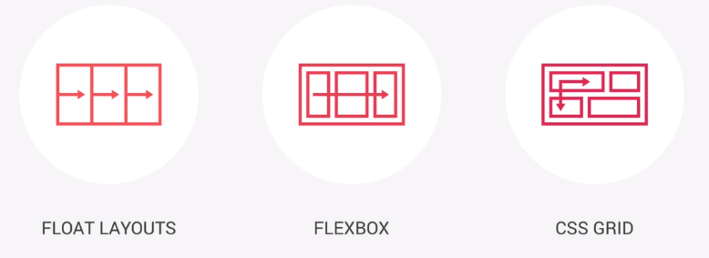To change styles on certain viewport widths(breakpoints), allowing us to create different version of our website for different widths

# 

Our current **NATOURS** project will use the **FLOAT LAYOUTS**

The idea is that in 2017 not all of the browsers supported flexbox or css grid, and so creating anything using FLOAT LAYOUTS is guaranteed to work and be supported by all browsers.

# FLOAT LAYOUTS

## HOW TO ARCHITECT AND BUILD A SIMPLE GRID SYSTEM USING FLOATS

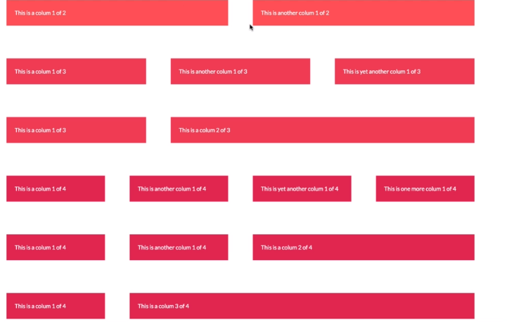

The **columns** should always be in a container. A column-container is what we call a **row**

**The space between columns and rows is called a gutter**

* **-Row-gutter(vertical)**

Space between **rows** is considered a **vertical-gutter(between-rows)**, because it separates the rows in a vertical axis

* **Column-gutter(horizontal)**

while the space between columns is considered a **horizontal-gutter(between-columns)**

Layout dimentions like these can and should be defined inside their own variables, so that we can easily later have them all in one place and change them from there if necessary.

//GRID variables

$grid-width: 114rem;

$gutter-vertical: 8rem; //80px

$gutter-horizontal: 6rem; //60px

**CREATING THE CLASS FOR ALL ROWS**

.row {

  max-width: $grid-width; /*1140px*/

  background-color: #eee;

  margin: 0 auto; /*trick to center one block element inside another block element*/

  //Setting up the gutter between the rows

  &:not(:last-child) {

    margin-bottom: $gutter-vertical;

  }

  //Insert clearfix before our columns

  @include clearfix; //.row::after{clearfix-content}

### Defining Row-width

.row{

    max-width:114rem; /*1140px*/

}

The industry standard is 1140px, but we’ve already seen that for all size properties we need to use relative units in order to keep everything responsive, and so we turn our px into rem (remembering that we set 1rem to 10px in our css reset)

Now, to keep the width responsive as well (able to shrink) our desired width should instead be set to **max-width**. (what it does is set the element to 114rem, but only if there is enough available space) Otherwise, the element will shrink and take up the available space that it has.

### Clearfix Reiterated as a **mixin**

When all of the elements inside the container are floated (and the container height is not defined or is set to auto) the container will naturally be left with the height of 0px

Why? Well, all of the child elements that it was wrapping(and adjusting hight according to them) have been floated(moved from the normal page layout/bumped one layer up). This will leave the parent container with 0px height (again, unless the parent element’s height was explicitly specified)

In order to keep parent elements from collapsing when their child elements get floated, we use clearfix. Now since clearfix generally is a hack that always has the same relative values and percentages within the **.clearfix{…}** declaration block properties, planting a clearfix declaration block each time we want to prevent a parent from collapsing (when using floats) kind of bumps the whole **Don’tRepeatYourself (DRY)** principle. Since the same css declaration code would have to get repeated multiple times.

### .Clearfix class as a MIXIN

This is where a **mixin** (variable containing and (where evoked) unloading a css declaration block) comes to its own. Clearfix class is a perfect candidate and example of what should be turned into a mixin

What a clearfix does, is append a pseudo element, after our parent element which will then clear the floats(floated children)

@mixin clearfix {

    &::after{

     content:"";//empty so we don't see the element

display:table; //standard clearfix display value

     clear:both;//clears both float left and right

//This is the actuall property that does the clearing(clear-fix, righ?)

    }

}

Note that when we apply a mixin, only the content inside the mixin get’s transferred, and so feel free to ignore the first curly braces and think about the mixin only representing the content inside those curly braces

Here we see the &::after being used, this means that whenever this mixin is inserted into a declaration block, the ::after element will be inserted after whichever is the parent element we’ve inserted our mixin into

For example:

.row{

Clearfix(); // Will be as if we’ve written .row::after{..clearfixContent…}

}

**Creating a row with two columns then a row of three columns**

 //#####FOR ALL ROWS WITH TWO COLUMNS

  .column-1-of-2 {

    width: calc((100% - #{$gutter-horizontal}) / 2);

    background-color: orangered;

    float: left;

    //Setting up the gutter between he columns

    &:not(:last-child) {

      margin-right: $gutter-horizontal;

    }

  }

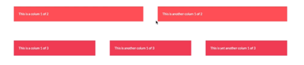

/#####FOR ALL ROWS WITH THREE COLUMNS

  .column-1-of-3 {

    width: calc((100% - (2 *#{$gutter-horizontal})) / 3);

    background-color: orangered;

    float: left;

    &:not(last-child) {

      margin-right: $gutter-vertical;

    }

  }

## **The [attribute]{ selector}**

[attributeName] {….} or [attributeName = attributeValue] {….}

When use a selector that searches for an attribute with a specified value, like in the second case, we also have a range of operators to work from

[alt^=”logo”] 🡪 Searches for any element which has an alt attribute that **starts with (logo)**

[alt*=”logo”] 🡪 _||_ which has an alt attribute containing the content of “logo”

We can also do this with classes(concidered attributes here) [class^=”col-“] {…declaration block.}

[class$="column-"] 🡪 Any class that ends with “column-“

Note that classes are here treated in the same way as attributes

**Example on the next page 🡪**

  //ATTRIBUTE SELECTOR sellects all columns, floats them and

  //adds a right margin(gutter) to all but the last column

  [class^="column-"] {

    background-color: orangered;

    float: left;

    //Setting up the gutter between he columns

    &:not(:last-child) {

      margin-right: $gutter-horizontal;

    }

  }

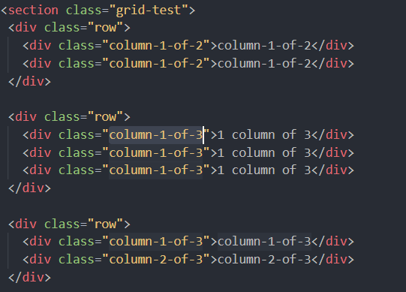

Note how we did not have to create an additional general class for each column, but have without the class “column” achieved the same effect, by specifying the exact way all various column classes start.

**Below, the usual (albeit less elegant way) we handled this without attribute slectors**

The alternative would be to add an additional general (column class to all columns)

Then target that class.

<div class="column column-1-of-3">1 column of 3</div>

    <div class="column olumn-1-of-3">1 column of 3</div>

    <div class="column column-1-of-3">1 column of 3</div>

.column{

    background-color: orangered;

    float: left;

    &:not(:last-child) {

      margin-right: $gutter-horizontal;

    }

  }

The difference in width between normal columns, and columns that span more than one column

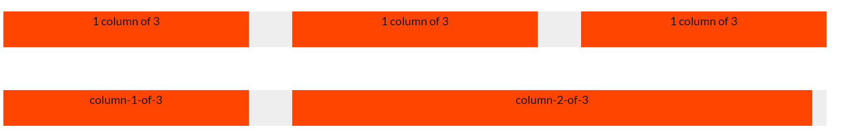

We can notice that the bottom **column-2-of-3** is not just the width of 2*(1/3), but it actually takes up the space of the second gutter which stands between the second and third collumn on the top row. This means that the width of the column that is 2/3ds length is actually:

**2*(1/3) + gutter-vertical**

## **PAGES folder**

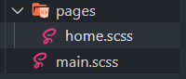

Here we have two main documents, but consider that this folder will grow to represent each unique style template for any of the page types we may eventually have on our website.

**The main.scss file**

What is not a page type is the **main.scss** file. This file is what actually connects all the various partial _.scss files throught the various directories and sub directories that contain them

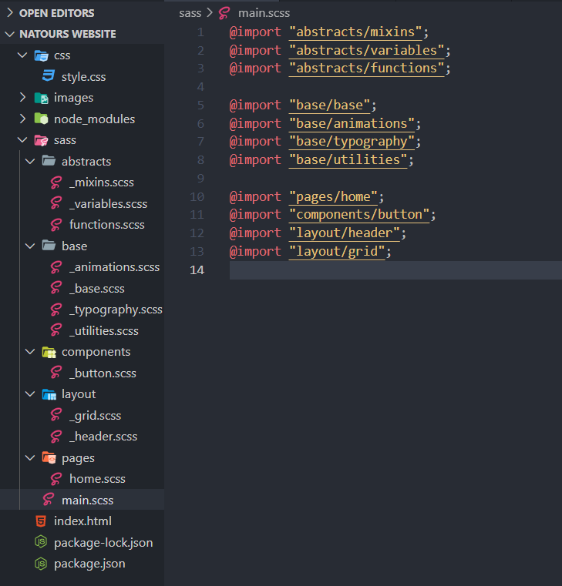

**While the HOME.scss** file would contain the styles that only pertain to the home-page 🡪 (index.html)

## Creating LINEAR GRADIENT inside TEXT

1.First we add a linear gradient background, making sure that the background is only as wide as the text, by specifying **display:inline-block;** property.

background-image: linear-gradient(

*to* right,

    $color-primary-light,

    $color-primary-dark

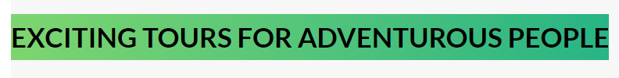

2.Then we clip the background to the text (so that the background around the text gets cropped off) so that the background now only exists behind our text (individual letters/characters)

-webkit-background-clip: text;



3.Adding a transparent color to our text: Since our background now dissapeared behind our black text color, we want to make it visible. To do this we simply have to make the text transparent and the gradient behind the characters will become visible, e-voilla:

 color: transparent;



**The full style: declaration block**

.heading-secondary {

  display: inline-block;

  font-size: 3.5rem;

  text-transform: uppercase;

  font-weight: 700;

  /*Making the text have a linear gradient */

  background-image: linear-gradient(

*to* right,

    $color-primary-light,

    $color-primary-dark

  );

  -webkit-background-clip: text;

  color: transparent;}

## **How :first-child :last-child pseudo elements actually work(REVISITED)**

Sometimes it seems like we are telling the selector that we attach this pseudo element to, to select the elements first/last child.

This is pretty much false.

We basically tell the compiler to look for the first child of any parent container that has the class/tag/id **of insert(selector):first-child{…}**

Examples

Body:first-child{} 🡪 Targets the body element itself (because the first **body** element in the html is at the same time the **only** body element.

**Body>*:first-child{…} 🡪Actually returns the first child of the body tag**

It says, give me the first child (*🡪of any element type) that has a parent container of body (**body>)**

So, if we want to have returned a first element of any particular container we would do the following:

**parentName>*:first-child{…};**

If on the other hand we would like to get a first element of a particular element type (div, input, etc…) we would do the following:

**parentElement>input:first-child{…};**

This would target the first child of the input tag, oh no, this would RETURN the FIRST INPUT ELEMENT, inside the PARENT ELEMENT.

**WITHOUT SPECIFYING THE PARENT CONTAINER**

**Input:first-child{…};** This targets all INPUT elements that are the first INPUTchild element of their parent containers.

**className:last-child{…}** Targets all the className elements that are positioned as the last className element within their parent container

### Pseudo elements with rows and columns example

-Every row will be inside a grid container and every column will be inside a row.

-Every row inside any grid-container, should have a bottom margin, except for the last row.

-Every column inside a row, should have a right margin, except for the last column.

**.row{ &:not(:last-child){margin-bottom: 8rem;}**

//Wherever the .row class element is positioned as a last-child, it will not have the margin

**.column{&:not(:last-child){margin-right:6rem;}**

//wherever the .column class element is positioned as the last child, it will not have the margin

## How absolute positioning works (REVISITED)

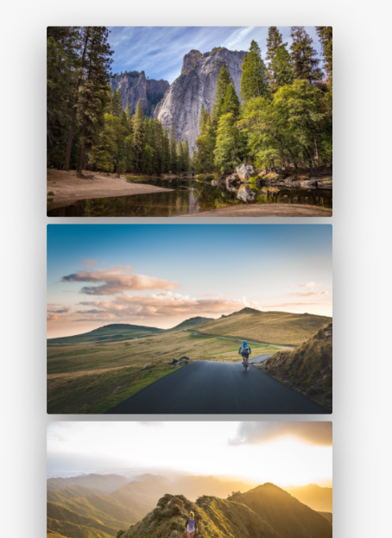Basically an absolute positioned element, is a position that is relative to a referenced element. (relative is a position relative to the page, absolute is a position relative to a referenced element)

This referenced element is by default the first encountered parent element that has the **position-property set to something (absolute/relative)**.

Note that by default the absolutely positioned elements, will appear on the 0x 0y coordinates of the parent element. Or better stated the 0x 0y coordinate of the absolute element will get positioned on the 0x 0y coordinate of a **positioned(relatively/absolutely) parent element.**

How that looks in practice. The absolute elements top most left position will appear on the parent’s **top: 0; left:0;**  positon, unless otherwise stated.

It is for the reason of reference, that we give the parent element of an absolutely positioned element the **position: relative;** property value.

 <div class="column-1-of-2">

            <div class="composition">

              <img

                src="images/nat-1-large.jpg"

                alt="Image 1"

                class="composition__photo composition__photo--p1"

              />

              <img

                src="images/nat-2-large.jpg "

                alt="Image 2"

                class="composition__photo composition__photo--p2"

              />

              <img

                src="images/nat-3-large.jpg "

                alt="Image 3"

                class="composition__photo composition__photo--p3"

              />

            </div>

**Before the absolute positioning(images were left/top of each other(depending on space)**

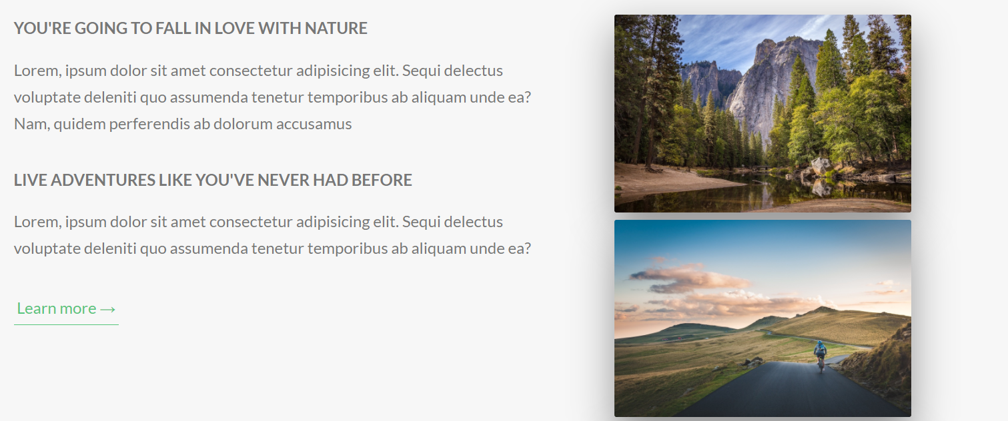

.composition {

Position: relative;

  &__photo {

    width: 55%;

    box-shadow: 0 1.5rem 4rem

rgba($color-black, 0.4);

    border-radius: 2px;

    position: absolute;

  }

**After being positioned absolute (notice that the images are now on top of each other)**

## 

#### **Scaling images and positioning elements (aside)**

**Note: You should, whenever possible, define the width of images in percentages, in order to keep the images responsive, so that they will nicely scale with the viewport.**

**The same thing applies to positioning elements, it is best to use % when positioning your elements. So that they always scale with your viewport**

## Scaling other images on the hover of one element

.composition {

  position: relative;

  transition: all 0.3s;

  &:hover &__photo:not(:hover) {

    transform: scale(0.98);

  }

  &:hover &__photo:not(:hover) {

    transform: scale(0.98);

  }

When you hover over the parent (.composition) class, only then target .composition__photo class elements, and if they don’t have a hover pseudo class over them  transform: scale(0.98);

This effectively has a selector that only gets activated on hover of it’s parent

parent:hover &thenSelect:

**.composition:hover .composition__photo:not(:hover){…}**

### **Creating a border(OUTLINE) with the image separated from the outline**

Here we can see that the image displayed is not actually touching the outline. For this we’ve simply used the outline property on **hover** to make the outline display with the width and color that it has. While on the original element we’ve set the **outline-offset** property to define how much we want our element to be apart(separated from the outline)

Bellow is the shorthand for the relevant parts of the code:

  &__photo {

    outline-offset: 2rem; /*20px*/

    // .composition__photo:hover

    &:hover {

      outline: 1.5rem solid $color-primary;

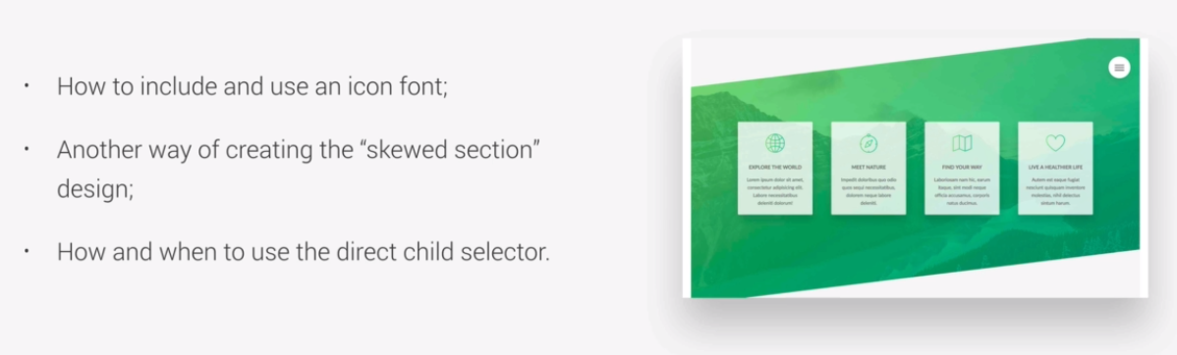**COMING UP:**

## Using Icons from Linea Icons

1.Go to **linea.io**

2.Download Icons

3.Unzip and in the icon folder find the following **fonts** folder and **style.css** folder, which contains the icon styles.

4.Copy those two into your project’s css folder, here: Natours Website/css, and rename the (icon)**style.css** file into **icon-font.css** so that your project css folder looks something like the following:

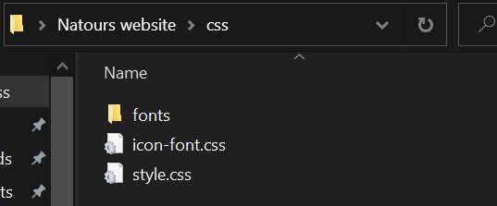

1. 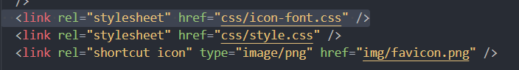Link the newly renamed **icon-font.css** into your **index.html** page.
2. Enjoy using the icons ^^

### **How to use Icons?**

Icons can actually appear whenever their class is inserted into the **classList** of literaly **Any** element.

To make them more, “au nou” and quite “fromagge” it is common practice to place them inside the now obsolete <i> tag (that used to be used for making text itallic)

<i class="icon-basic-world"></i>//And now the icon will appear in its default size

Yaay freeloading! ^____^

Note that any other tag can be used, but since this one does nothing, it is a good standin

Were we to, for example want our icon to act like a link, we can without a hitch attach the class to an anchor tag:

<a href=”#” class="icon-basic-world"></a>

A link and an Icon, babe… What more do ya need?

### **Important note on using predefined layouts**

We’ve made our float-grid, now whenever we use it, remember to never apply any additional styles to our layout elements(grid in this case) in anyother file ( other than _grid.scss for example). So unless it is a layout folder file for that particular layout element, never-ever touch the layout styles.

If you want to style your elements within the layout you are using, simply create another div inside the layout container (whatever it may be) and style that new element inside the layout container.

**THIS IS BEST PRACTICE**

## **Applying a Linear-Gradient to an icon**

Remember that Icons area basically jovially shaped fonts…I mean they Are fonts, which means we can treat them and style them the same way we do text. As you can se below:

__icon {

    font-size: 6rem; //Icon is actually a font

    margin-bottom: 0.5rem;

    //Creating a linear gradient for the icon

    display: inline-block; //to have the background only as wide as the icon

    background: linear-gradient(

*to* right,

      $color-primary-dark,

      $color-primary-light

    );

    -webkit-background-clip: text;

    color: transparent;

  }

The code really gives us this cool gradient color. Just remember to use your own variable colors. Here the variable names are left in to be used(disregarded) at your own discretion, though they are quite generic by the rule of best practice in the naming convention, so there is no reason your website should have a color of a different name, even though the colors between them can be completely different, savvy?

## Font inheritance on parent elements (REVISITED)

Remember that you do not have to declare font size properties for each and every paragraph, h1, h2,h3 individually

Let’s imagine that we have a container element, a <section> and in that section we have three <h1> elements and four paragraphs <p>

We do not have to access these elements in order to define their font

We can simply state to the parent: **section{font-size:2rem;}**

and the <h1> and <p> will inherit the font size of 2rem

## **CASCADE AS IT RELATES TO INHERITANCE(REVISITED-IMPORTANT!)**

We define the cascade as the process of finding the value for each individual property on each specific element, based on rules whose selectors match that element, taking into account order, specificity, and importance. If no rule specifies a particular property, then that property takes on the **default** value. Note that this process does **not** include inheritance anywhere.

In other words, inheritance is not part of the cascade. Inheritance happens if and only if the property is inheritable, **and** the cascade results in no value for the propertly.

The CSS spec specifies that font-weight and font-size are inherited. This simply means that any element with no alternative rule for those properties will cause them to inherit the final, computed values from their parent.

## **DIRECT-CHILD ALL-CHILD selectors**

Imagine that you have a parent element <section> and in it there are two divs with paragraphs

<section>

<div class=”container1”><p class=”p1”><a></a></p></div>

<div class=”container2><p class=”p2”><img/></p></div>

</section>

### **ALL-CHILD SELECTOR(parentElement *)**

The **all-child** selector targets all children of an element (regardless of how deeply they are nested):

**section *{background: powderblue;}** 🡪this will target all of the children elements(not the <section parent>) inside the block. (please notice the space between **selector** and **(*)**, mui importante!

So in this case of using the “ALL-Child selector” 🡪 **selector *{…}** the following elements will have the powderblue background applied to them:

.container1, .p1m, .container1 .p1 a, .container2, .p2m, .container1 .p2 img**{background:powderblue;}**

### **DIRECT-CHILD SELECTOR (parentElement> *)**

The **direct-child** selector targets only the first level child elements of the parent container (THE DIRECT CHILDREN)

**section> *{background: powderblue;} 🡪 container1, container2{background:powderblue;}**

## Skewing an entire section

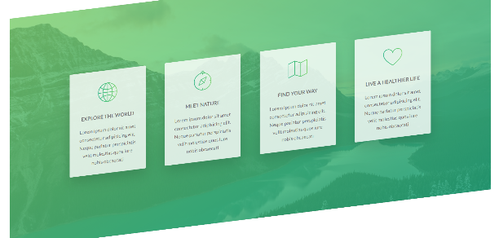

The section is called the **.section-features.**

We can see that after skewing the section and all of its child elements get skewed together… Har, har… -_-

To get the child elements to return to their original position, we simply have to skew all of the .section-features’s child elements in the opposite direction that the section itself skews in

.section-features{

ransform: skewY(-7deg);

  //Below is a Direct child selector

  //.section-features>*

  & > * {

    //skewing the child elements in the opposite direction

    // skew 7deg + skew -7deg = skew 0deg

    transform: skewY(7deg);}

  }

}

Now the section is skewed while the child elements are not

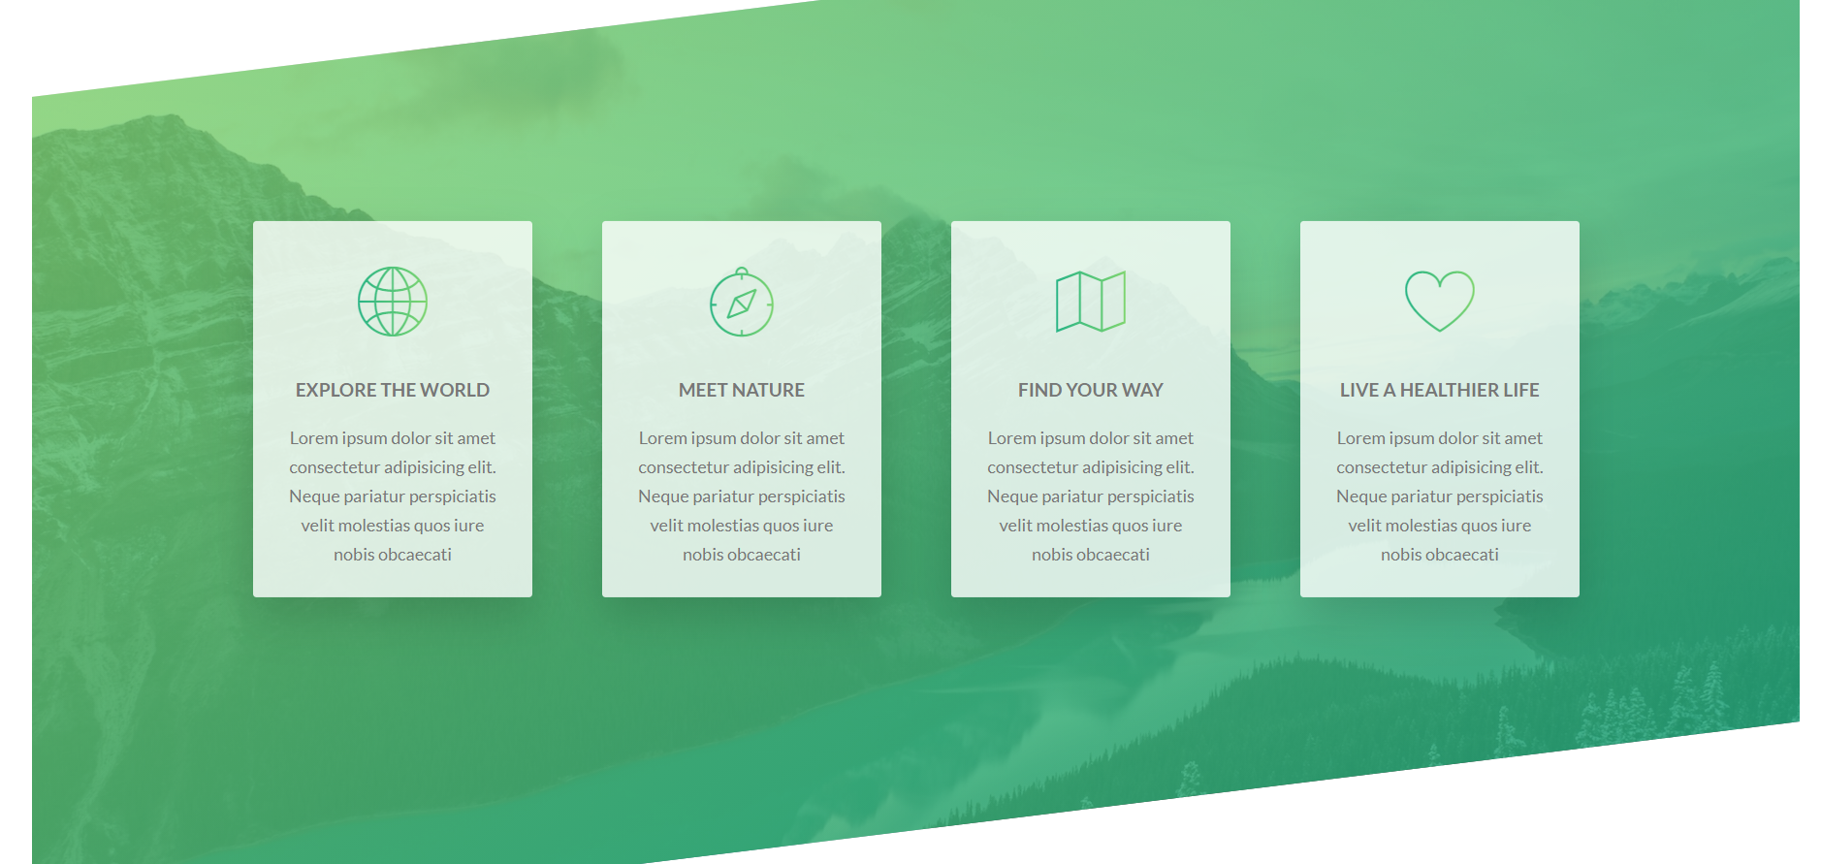

## **Using negative top/bottom-margins to move entire sections up or down**

Just a brief note to say that negative margins really are the conventional way of moving entire sections up or down, even ignoring the top/bottom margins of intersecting elements around them.

In short, if you want to push your section/block element up or down, and also want to make sure you don’t push the element above or below it: 🡪 use negative margins

**margin-top: -10rem;**

**margin-bottom: -10rem;**

It is a fine practice(not lazy web-design), so feel free to use it when necessary.

The skewed section from before, would leave more empty space above it, than was before, in those cases, when we style sections so that they leave a lot of white space below or above them, we should use negative margins, either to bring the skewed(for example)section closer to the section before **.skewedSection{margin-top: -10rem}** or to bring the section coming after it closer as well

**nextSection{margin-top: -10rem}** covering the artificially created empty space in the process.

### **Background Image selector**

.someClass{

        background-image: linear-gradient(

*to* right bottom,

          $color-secondary-light,

          $color-secondary-dark

        );

      }

Note that we cannot use linear gradients in any other property, as linear gradients are classified as images. So if we want to have a composite background of an image and one or more overlay, we will put all of them inside one background image property. And in the cases where we would only want to use a single linear gradient, remember that only the **background-image** property can accept its value.

## On fixing a collapsed parent element when their child is set to absolute position

Differenly than the case with colapsed float parents, we cannot use a clearfix method to fix a collapsed relatively positioned parent, due to absolutely posittioned child elements, so instead we have to simply define the desired size(height) of both the relative parent as well as the size of the absolute child element

This is important to note as more often then not, we let the parent element height get defined by the height content of the child elements. In this case, as the absolute child elements get taken out of the normal website flow, the parent loses its content space and collapses. For floats, we’ll reiterate, the fix is the clearfix MIXIN in SASS, while for absolutely positioned element’s parent, the only fix is to explicitly define the parent’s height.

## **Traversing the directories from SASS files**

Whenever we want to link urls from our SASS file, we should ignore the current folder directory of the sass file we are writing in, because all of the SASS files from our project, will ultimately get processed and sent to our main **css/style.css** file.

This means that when referencing from a SASS file, we should behave as if we are doing it from our **style.css** folder, as that is where our reference, and code, will actually be compiled in the browser.

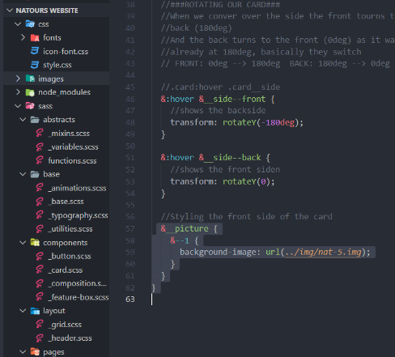This is why the following is true

Going one level up then into the images folder from the current sass **_card.scss** file, would not work, as our file is currently in the **components** folder, so one level up, our reference would enter into the SASS folder, and in that folder there is no directory with the name **images.**

On the other hand, if we are to know that all the SASS files will end up in the main **style.css** file, and knowing that, if we were to plot a link from that file to our desired background image, the link would indeed need to take us one level up (../), then into the images folder (../images) then to the desired image (../images/nat-5.jpg)

**Takeaway:** reference directory paths from your SASS files, as if you are inside your main css file, because that is where all the processed SASS code will actually get compiled.

## Unsplash Free Image Website (RESOURCES)

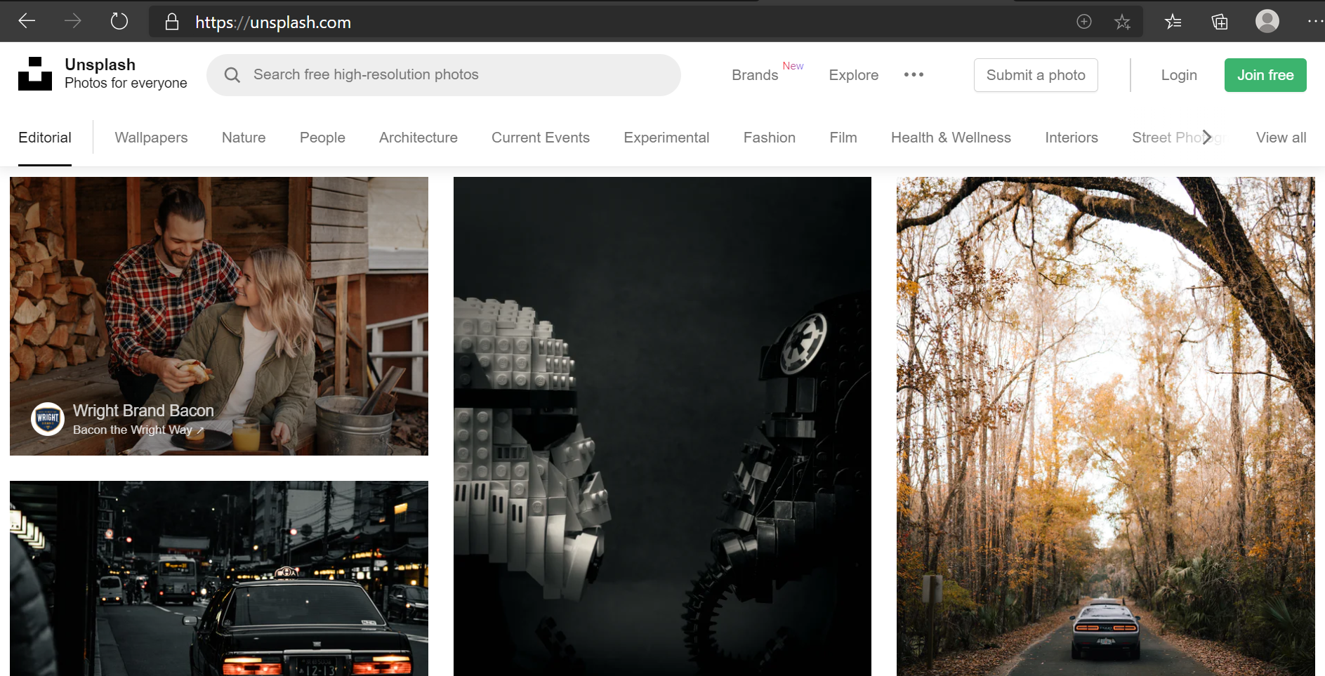

[Beautiful Free Images & Pictures | Unsplash](https://unsplash.com/)

## Backface visibility (revisited)

What this does is basically tell us whether or not we want to see the backside of an element, consider the backside the inverted version of the element(as our elements are not cardboard cards to be painted on one side and to remain plain on the other side). When we give some background to our element it actually fills up both the front and the back of the element (but the back is inverted) as can be seen below:

This is the front and we can see that the text (“back) is normal, and not inverted, but since this card has a hover functionality where it rotates 180degrees, let’s see how the backface looks:

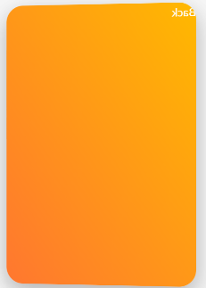

Same color, just notice how the gradient is on the other side, and how the text is inverted, as we are looking at the back of the text, in fact.

If we want to (for example make a card that has two sides, we must make the backface invisible, in order to not see the back of the side that is rotated away from us.

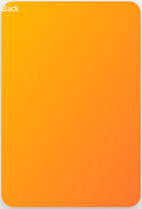This is what happens when backface is visible. If we want to be able to rotate an element 180 degrees and for it to turn tranparent (basically disappear, and show the any elements and backgrounds behind it) We’d use the **backface-visibility:hidden;** property value.

## **Rotating-Card component**

### (As complex as it is awesome!)

A very complex component in web-design

A card that rotates Is in fact created by two cards, that are positioned absolutely and aligned at the top: 0, left:0; position relative to their shared parent element  
This means that they overlap each other.

Something that is utiilized to make each other selectively visible one after the other, on rotation, is the backface-visibility property.

If the **backface-visibility** is set to **hidden** for both elements, that means that only the element that is currently facing us with its normal layout (front side) is going to be visible.

Or to summarize the principle in an even more simple manner

When an element has **backface-visibility: hidden;** it becomes transparent (invisible) so the element behind it becomes visible.

If we were to have two elements with **backface-visibility: hiddent**; one on top of the other,

If the one on top is turned 180degrees (flipped) the one behind it will become transparent. Now there is the aspect of animating them both, so in that sense( they both have to turn) and it makes sense that when the front image turnes 180degrees, the back of the image turns 180degrees as well, so that we have an animation of both images turning (and not the front rotating to unveal a static image behind it.

### **Setting up the card**

1.Have both image-cards on top of each other, positioned absolute in a position:relative 🡪 parent.

2.Have both front and back images apply the property value of **backface-visibility:hidden**

3.The front image will rotate around the Yaxis 180degrees, which means that the starting position of the front image is **transform:rotateY(0);** While the starting position of the backfaceImage is **transform:rotateY(180deg)** its backface is already showing so it is invisible. In other words,

Front image starts at 0degrees rotation (stays unchanged)

The back-image at the start is rotated (180deg) its backface showing so it is transparent.

### **Rotating the card**

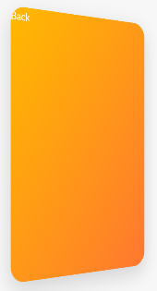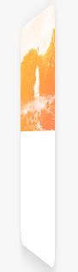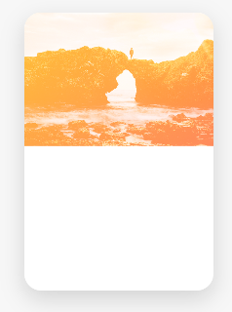

On hover we want the following:

**- back image to become visible(no longer transparent)** (that meanst that it should rotate so its backface is turned to the back, and the front-face turned to the user)

**-front image to become invisible(transparent)**(meaning that it should rotate so it’s invisible(transparent)backface is turned to the front, so that now the user can see throught the transparent backface of the front image, the rotating and visible part of the back imageas it too becomes visible (as it turns from its own backface to frontface)

.card {

  //Functionality

  perspective: 150rem;//perspective has to be set on the parent of the rotating child

  -moz-perspective: 150rem;

  position: relative;

  height: 50rem;

//gives the parent a height after its absolute children move out of the parent layout

  &__side {

    color: #fff;

    font-size: 2rem;

    height: 50rem;

    width: 100%;

    transition: all 0.8s ease;

    position: absolute;

    top: 0;

    left: 0;

   backface-visibility: hidden;

    border-radius: 30px;

    overflow: hidden;//hides the background image sticking over border radius

    box-shadow: 0 1.5rem 4rem rgba($color-black, 0.15);

    &--front {

      background-color: $color-white;

    }

    &--back {

      transform: rotateY(180deg);

  //.card:hover .card__side

  &:hover &__side--front { //when the parent is hovered rotate the child element

    //shows the backside

    transform: rotateY(-180deg);

  }

  &:hover &__side--back { //when the parent is hovered rotate the child element

    //shows the front siden

    transform: rotateY(0);

  }

 <div class="column-1-of-3"> <!—A container for the card (defines its dimention)🡪

            <!--Card1-->

            <div class="card">

              <!--Front of the card-->

              <div class="card__side card__side--front card__side--front-1">

                <div class="card__picture card__picture--1">

                  &nbsp;<!--Empty space html symbol-->

                </div>

                <div class="card__heading">Heading</div>

                <div class="card__details">Details</div>

              </div>

              <!--Back of the card-->

              <div class="card__side card__side--back card__side--back-1">

                Back

              </div>

            </div>

          </div>

Note that the two images mentioned above are in fact two <div> elements with a background-image property.They are both inside the <div class="card"> parent element, which has position relative, while the children “card__side—front” and “card__side—back” have the position:absolute; top:0; left:0 🡪 referencing the top left position of their parent “card” div element.

Note that their specific styles are defined in the modifier &--front and &--back classes, while their position (as they are both one side of the card) is defined in their more general shared class “card__side” referenced nested inside the parent “card” element as &__side{position:absolute;…} It is something to note.

To reiterate &--front and &--back are two divs that are normally stacked on top of each other(being block level elements) taking the whole horizontal space of a parent column-layout component, that divides a row into thirds.

Being block level elements, the only way to make them stack on top of each other is to absolutely position them, relative to their parent “card” element, that is currently constrained inside the the space within the “column-1-of-3

So the block elements stack one over the other, all the while remaning inside the inherited space of the parent . <div class="card">’s parent 🡪 <div class="column-1-of-3">

The size of the card later defined by styling the <div class="card"> element and its children (as we should never style the layout element-components that we use for aligning our elements on the webpage, which are in this case the components used to create a grid using floats by floating column divs inside row divs, whereby we’ve here borrowed a row and a floated column: <div class="column-1-of-3"> (always create additional divs for the elements you insert into the layout components, and style those instead!!!)

## Box Decoration Break Property

What this property does, is allow to define how the element behaves if it breaks into a new line.

Usually if we set a padding property for an element, and it breaks into a new line, the browser would treat that element as a single entity(even though it broke into two lines)

Below the heading with a background and a padding, broke into two lines because it could not fit the heading into the container that had a width of 75% of the total width of the image.(we squashed the heading into two parts by making the parent element width small,basically)

padding: 1rem 1.5rem;

Notice how on this image the left padding starts on the top left part of the heading, but is then only applied again on the bottom left of the second part of the heading. This is because, by default, the browser still treats elements that break into multiple parts to fit the container, as one single element, and so the padding is applied at the beginning of that single element, and at its end, ignoring completely the break-points

-webkit-box-decoration-break: clone;

padding: 1rem 1.5rem;

In this case, using the **box-decoration-break** property with the assigned value of **clone,** we are cloning the properties of the box, on each of the break items, so that whenever this element breaks, each broken part of this element will have the same styles applied on it, as if it was an instance of the entire element itself. Or in simpler terms, each broken part of the heading would again have the padding applied/cloned on itself, as if it were a separate element.

  &__heading-span {

    padding: 1rem 1.5rem;

    -webkit-box-decoration-break: clone;

    &--1 {

      background-image: linear-gradient(

*to* right bottom,

        rgba($color-secondary-light, 0.85),

        rgba($color-secondary-dark, 0.85)

      );

    }

  }

## **Center align absolutely positioned elements(revisited)**

  &__callToAction {

    //Aligning an absolutely positioned

    position: absolute;

    top: 50%;

    left: 50%;

    transform: translate(-50%, -50%);

  }

What we are doing basically is:

1.first centering the child elements top left corner on the center of the parent element: top: 50%; left: 50%;

2.Then moving the center of the child element itself to the position where currently its top left corner resides.

So we translate it by half of its own width to the left on the X axis so that now the center of the element is directly lying on the y axis of the parent element

3.Then we proceed by moving the element up by half of its own height on the Y axis, therefore placing the exact center (50% threshold) of the element’s height on the parent X axis

transform: translate(-50%, -50%);

### Clip-path property breaking the overflow property

Whenever we use clip path property, for some reason It happens that it breaks any set overflow property (specifically **overflow:hidden;**)

To remedy this, simply add a border radius to the image/div you used the clip path on, as well as to the parent element, the clipped path image inherited the border radius from (before it stopped working)

.parent {

    height: 52rem;

    width: 100%;

    transition: all 0.8s ease;

    position: absolute;

    top: 0;

    left: 0;

    backface-visibility: hidden;

**border-radius: 5px;**

&__picture {

    background-size: cover; //Makes the entire image fit its container

    height: 24rem;

    background-blend-mode: screen;

    -webkit-clip-path: polygon(0 0, 100% 0, 100% 85%, 0 100%);

    clip-path: polygon(0 0, 100% 0, 100% 85%, 0 100%);

**border-top-left-radius: 3px;**

**border-top-right-radius: 3px;**

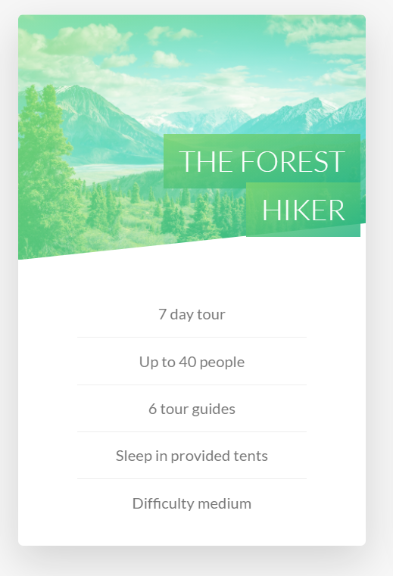The border radius was set for the entire card (the parent)

Now on the image we used clip-path property, so the ednges of the image overwritten the overflow of their parent element, and stuck out with their sharp angles at the top.

To remedy this, we’ve explicitly added another border radius, just to the top of the image itself.

So the entire card has a border radius, as does the image on its two top corners.

And as a solution this is pretty conventional, so keep this problem and solution in mind if you encounter it down the road.

## **Perspective property**

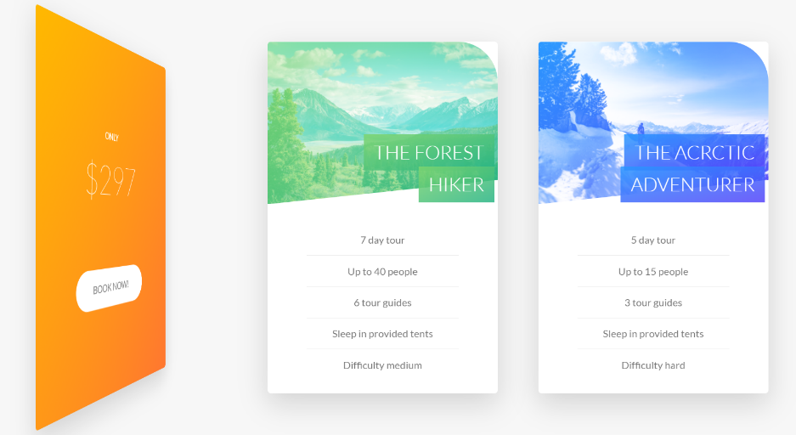**With perspective**

On the left is the element that has a transform rotate 180deg Y axis property applied to It, as well as a perspective: 80rem //800px, which makes it appear as if one edge is closer to the sccreen, while the other edge is farther away from the screen

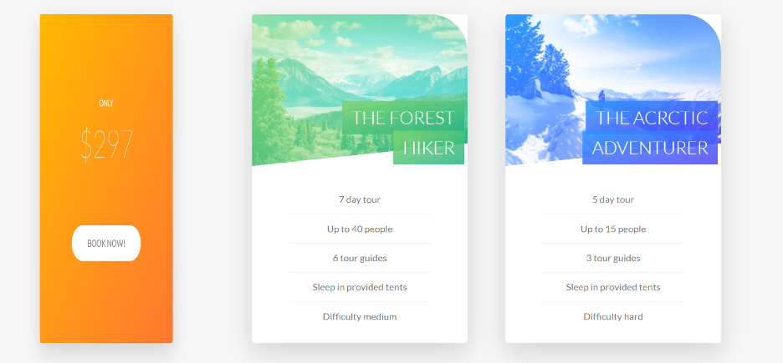**Without perspective**

To contrast that, if we add the same rotate value to the same transform property, but don’t set a a value to the perspective property(leave it at default 0) what happens is, the element appears to squash itself around the Y axis(horizontally) instead of appearing to actually rotate. This is because no perspective is simulated, so the edges of the element rotating, don’t move (adjust size) relative to the distance of the viewport. If we add, for example perspective 80rem, this would mean that the object is simulated to appear as if it was 800px away from the viewport (and creates the illusion of depth by increasing the size of an edge that is towards the screen and decreasing the side of the element that is turned away from the screen)

.card {

  perspective: 80rem;

  -moz-perspective: 80rem;

}

  //Perspective: makes the edges appear closer to the viewport

  //If they rotate close to the center of an object during a transformation

  //Closes distance(depth) of the object from the viewport

  //Small value means the object gets REALLY CLOSE to the viewport

## **Shaping** **content** **around** **a** **floated** **element**

The goal is to have our content shape around the circle element

.story {

  width: 75%;

  margin: 0 auto; //to center it

  box-shadow: 0 3rem 6rem rgba($color-black, 0.1);

  background-color: $color-white;

  border-radius: 3px;

  padding: 6rem;

  padding-left: 9rem;

  font-size: $default-font-size;

  transform: skewX(-12deg);

  //CREATING THE CIRCLE SHAPE

  &__shape {

    width: 15rem;

    height: 15rem;

    background-color: powderblue;

    //Floating element to make elements around it shape around

    //(shape outside) only works if the element is floated, and only works

    // if the element has defined dimentions

    //also note that the circle is here defining the layout behavior not

    // the shape itself, to change the shape of the object, we still have to use clip path

    float: left;

    -webkit-shape-outside: circle(50% *at* 50% 50%);

    shape-outside: circle(50% *at* 50% 50%); //exact circle

    -webkit-clip-path: circle(50% *at* 50% 50%); //(radius,Yposition X position)

    clip-path: circle(50% *at* 50% 50%); //50%radius is 15rem/2 (width of the circle is 2radisu == 15rem

    //Best way to move floated objects is to transform translate them

    //manually skew(re-adjust) individual elements in the opposite direction of the parent container

    transform: translateX(-3rem) skew(12deg);

  }

  //Images always and without exception need to have a width or a width

  &__img {

    height: 100%; //100% of the parent circle

    //If the image does not display well in the container, try

    //switching from heigt to width and vice-versa

  }

  &__text {

    //manually skew(re-adjust) individual elements in the opposite direction of the parent container

    transform: skew(12deg);

  }

}

 <div class="story">

            <figure class="story__shape">

  <img class="story__img" src="images/nat-8.jpg" alt="Person on a tour" />

</figure>

            <div class="story__text">

              <h3 class="heading-tertiary .utility-margin-bottom-small">

                I had the best week ever with my familly

              </h3>

              <p>

                Lorem ipsum dolor sit amet consectetur adipisicing elit.

                Accusantium, et doloribus soluta tenetur quibusdam adipisci!

                Accusantium, et doloribus soluta tenetur quibusdam adipisci!

              </p>

            </div>

          </div>

Note that when creating the skew of our story section parent element, we could not simply skew the parent in one direction then skew all direct child elements using the direct child selector **story>*{ skewX(oppositeDirection :P )**

Because we already have a transform property set on one of the child elements (the shape: transform: translateX(-3rem)) and only one transform property can be applied to an element at a time (so in the cascade these two transform properties (the parent’s direct child skew transform value and the child’s translate transform value) are conflicting, and the one with the greatest importance, specificity or order will be the only transform value to get applied.

This means that we cannot skew the child elements from the parent using the direct children selector, but that we have to, instead, specify the skew in the opposite direction, for every child element within the story container. ( the text content div and the shape – div)

**The best way to move floated elements around is to not use margins, but instead rely on transform translate properties**

**There can only ever be one transform property applied on a single element** ( in the future, skew, translate, rotate, etc… will probably be made as css properties and not transform values, but until then remember this very well! Two transform properties on a single html element are always going to be conflicting properties within the css cascade, and only one will ever be compiled into the calculated value

## On hover image zooming out as it blurs, and overlay text appears(animation)

### <figure> and <figcaption> syntax tags

Using the <**figure>**  and <**figcaption>**  html sintax markup. These tags are used to tell the browser that this is a figure(usually and image connected to a type of content /usually text-caption) This means that image contents are, just like in word-captioning defined as figures comprised out of an image and a caption

 <figure class="story__shape">

<!—Image component🡪

              <img class="story__img" src="images/nat-8.jpg"alt="Person on a tour"/>

` <!—Caption component🡪

              <figcaption class="story__caption">Mary Smith</figcaption>

  </figure>

### **Css filters**

Used to add filters to images and backgrounds(opacity,brightness, sepia, saturation, etc…)

Use these to basically apply photo filters to images and backgrounds… How cool is that, doggo!

 &:hover &__img {

    transform: translateX(-4rem) scale(1);

    filter: blur(3px) brightness(80%);

  }

### **Putting it all together**

.story{

  &__caption {

    color: white;

    text-transform: uppercase;

    font-size: 1.7rem;

    text-align: center;

    transition: all 1s;

    //We'll be using the absolute position centering method

    //With the difference, that we want the element to initially appear bellow center

    position: absolute;

    //Align to the parent

    top: 50%;

    left: 50%;

    //Setting the initial state (before the hover animation)

    transform: translate(-50%, 20%);

    opacity: 0;

    backface-visibility: hidden;

  }

  &:hover &__caption {

    //Center align with absolute positioning to the center of the image

    transform: translate(-50%, -50%); //centering the element itself

    opacity: 1;

    backface-visibility: hidden;

  }

  &:hover &__img {

    transform: translateX(-4rem) scale(1);

    filter: blur(3px) brightness(80%);

  }

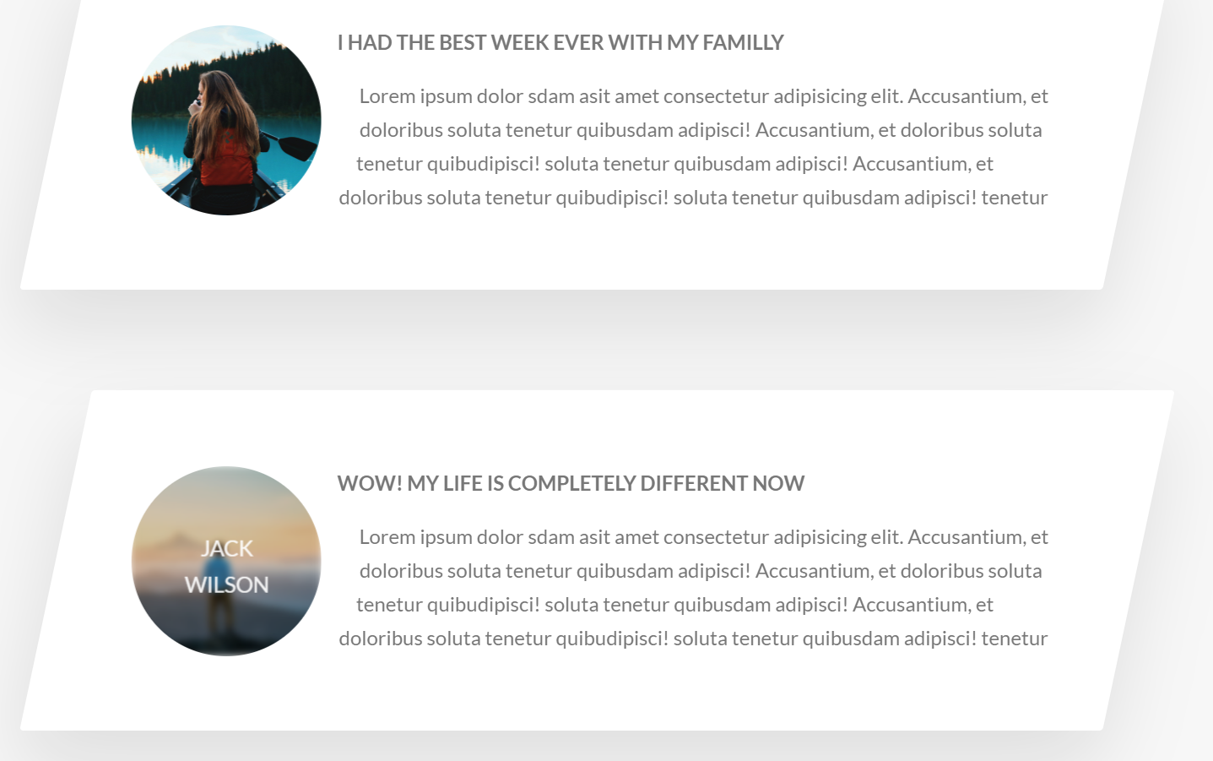

## **FIXING ANIMATION GLITCHES STARTER PACK**

**//Fixing some animation glitches**

**backface-visibility: hidden;**

**overflow: hidden;**

If animations are glitching or if content overflows (clips through the parent element) remember these two handy properties, and overflow alone, does wonders, if clipping elements outside of a container is allowed (Generally if you want a container to have child elements that are visibly overflowing (positioned outside) of the borders of the parent, use absolute positioning instead of relying on elements overflowing. Using absolutely positioned child elements will make the parent’s: **overflow:hidden;** property ignore the absolutely positioned children, letting them maintain their visibility even if they are outside of their containing parent element.

## **Adding a video background to a section (html5 video element)**

Get some free background videos from **COVERR.co**

**(**[Free Stock Footage | Royalty Free Videos for Download | Coverr](https://coverr.co/))

****When you download from this site, you will get both video formats used in the <video> <source> tags. Web, **video/mp4 and video/webm**

The tags that you’ll be using to embed videos

<section class="section-stories">

        <div class="background-video">

          <video class="background-video__content">

            <source src="images/video.mp4" type="video/mp4" />

            <source src="images/video.webm" type="video/webm" />

          </video>

        </div>

<section/>

### **Positioning and sizing the background overlay(div)**

You want to have an absolutely positioned div positioned over the section element that you are creating a background image for. Make the background-video div the same height and width as the section you want it to cover. Give it a z-index so that it is placed behind the section, then give the section a transparent background, e voila, you got a working background video.

### **Getting the video source using the <source> html5 tag**

Videos are not sourced like images, using the src attributes inside the video tag (even though they come equiped with one), instead, for sourcing videos we will be using a separate **source** tag.

In the source-tag, we’d pass a directory path to **its** src attribute (so not the video tag’s src, but the source’s src) as well as the video type, in the **type** attribute, so that the browser knows how to render the video. **Mp4 and webm.** Having one video in each format makes sure it runs in all browsers!

## **Assigning commands to the video tag**

In order to control the way our video behaves, we have various html commands supported for our use.

Generally for background videos we’d be inserting the following commands:

* **Autoplay**(makes the video play automatically/usually bad practice if it is not a background vid
* **Muted**(Users should always be given the option to chose sound, also, background vids generaly don’t need to have a sound)
* **Loop** (if loop command is ommited, the video will play once per parge reload, by default)

 <!--Background video overlay-->

        <div class="background-video">

          <video class="background-video__content" autoplay muted loop>

            <source src="images/video.mp4" type="video/mp4" />

            <source src="images/video.webm" type="video/webm" />

            Your browser is not supported to display the video!

          </video>

        </div>

The comments placed inside the video tag (the text inside) is set to appear in those cases that the browser does not support the sourced video’s. (Old internet explorer versions, what else? :P

#### **Note on changing background opacity**

Never use the **opacity** property if you want to make a background of a section transparent, as a lower opacity set on a parent element is inheritable. This means that all the text, images, and other stuff of the child elements will also be as transparent as the parent(unless a conflicting opacity property is set for them specifically as well)

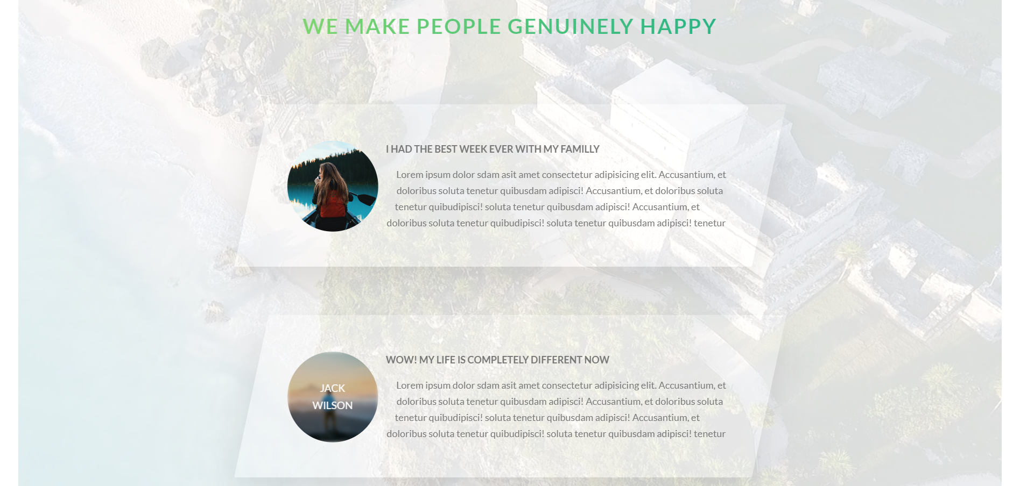

### **Object-fit property**

.parentContainer{

height:90rem;

width:120rem;

&__video {

    height: 100%;//90rem

    width: 100%;//120rem

    object-fit: cover; //similar to background-size:cover;

    //It makes the element fill its entire parent while still maintaining its aspect ratio

   }

}

Just like **background-size: cover;** is used to make a background-image, stretch over to fill an entire parent element(without losing its original aspect ratio) **object-fit** property does the same for other html elements, that are not background-image/types, like <videos>, and actually <img> tags too!

How it works is, whenever we have an <img> or <video> inside a parent container element, we can make those img/video elements cover the entirety of the parent element without losing their aspect ratio, by giving the video/img selectors the property of **object-fit:cover;**

**Object-fit: cover; 🡪** Maintains aspect ratio (covers the entirety of the parent, clips what can’t fit)

**Object-fit:fill; 🡪** Does not maintain aspect-ratio but makes the object fit the parent (stretches or shrinks in the x or y axis)

**Object-fit:contain; 🡪** Stretches or shrinks the video/image, making sure not to crop anything from the video or image (re-adjusts the size in order to make everything fit without cropping)

### **How to define the size of your containers**

It is important to let the content of our containers define the size of the container. Add padding and margins so that the content appears to be placed inside a predetermined container size, yet, ultimately, the sizes of our containers are no predettermined by height or width, but just by the content inside them.

Note that layout elements, on the other hand, often have a predetermined hight or width.

Also, BACKGROUND IMAGE DOES NOT TAKE UP ANY SPACE IN YOUR CONTAINER,. The background image will only ever display if the element it is implemented on has a defined size.

### **Playing with the use of the linear gradient and a picture as a background image**

//we want the gradient to be on top of the image, and so

  //it will be the first background-image property value

  background-image: linear-gradient(white, transparent),

    url(*../images/nat-10.jpg*);



To top and to left, gradient from white to transparent. The effect is pretty kickass, honestly!



### **Creating a two color background image using linear gradient(Solid color gradient technique)**



 background-image: linear-gradient(

      105deg,

      rgba($color-white, 0.9) 0%,

      rgba($color-white, 0.9) 50%,

      orangered 50%

    ),

    url(*../images/nat-10.jpg*);

105deg, defines the gradient angle relative to the horizontal X axis(0 is completely horizontal) The percentages define at which thresholds the color should change.

At 0 and 50% we have the same color white with a transparent opacity.

But at 50% we also have the orangered 50% defined threshold.

If two colors share the same % treshold, then there is no space for the gradient to turn from one color to the other. This is how we can use a linear gradient to create sharp angles and lines, because by defining two colors at the same percentage, we are creating a sharp line between the two colors. **If it was to be white 45% orangered 50%, then the 5% between them would contain a gradient between the two colors.**

 If there are no % between two colors(then the color immediately turns from one to the other, as can be seen on the image above. And in the case of the image below, we have a two color gradient and three thresholds: white0% white50% transparent50%, overlayed over an image, by making the gradient the first value in the background image property, and the image url the passed as the second value.

.book {

  //we want the gradient to be on top of the image, and so

  //it will be the first background-image property value

  background-image: linear-gradient(

      105deg,

      rgba($color-white, 0.9) 0%,

      rgba($color-white, 0.9) 50%,

      transparent 50%

    ),   //notice how the solid color gradient has two colors at the same threshold%

    url(*../images/nat-10.jpg*);

  background-size: 100%; //same as cover, cause (cover == 100%)

  border-radius: $border-radius-default; //3px

  box-shadow: 0rem 1.5rem 4rem rgba($color-black, 0.3);

  height: 50rem;

}

## Creating our Booking-Form

### **Styling the default user-agent css on FOCUS**

&__input {

    font-family: inherit; //manually set the inheritance on

    font-size: 1.5rem;

    padding: 1.5rem 2rem;

    //Best to give buttons and input elements more padding on the sides

    border-radius: 2px;

    background-color: rgba($color-white, 0.5);

**border-bottom: 3px solid transparent;**

**//transparent placehodler for the colored border, to keep the same box-size**

**&:focus {**

**outline: none;**

**box-shadow: 0 1rem 2rem rgba($color-black, 0.1);**

**// box-shadow: Xdirection Ydirection BlurDistance color**

**border-bottom: 3px solid $color-primary;//focus colored border**

**}**

  }

Notice how when we remove the outline, we still set a box shadow and a border to our inputs (on-focus) This is in order to make it clear to the user which input element is currently being focused on. So whenever we remove the default focus-queue for the user, we have to make sure we place something else to denote the fact that the element is in focus, especially for those users that are using touchscreens or the keyboard to traverse the webpage, so they would know which element they are currently focused on, and the fact that they focused on an element successfully at that.

### **Adding a transparent border to elements that get a focus-colored border**

If our element is going to get a border on hover, focus or active state, we must realize that adding said border to it, will change it’s size (box-sizing:border-box) ignores borders after all, and adding a border gives the element’s box a a larger height/width in the ammount of the specified border size.

To make this a non issue, if we expect the border to transform from none to a colored border, we may simply add a transparent border of the same size and type as the colored one, for the initial state, and then on hover/active/focus, define the colored border for the element of the same size. This will not change the element box-size, and the border will not induce a shift of the elements positition and size, or that of the elements around it.

### Box-Shadow property

 // box-shadow: Xdirection Ydirection BlurDistance color

* **X-direction**: how far we want the shadow to go (+value is to the right –value is to the left)
* Y-**direction**: how far we want the shadow to go (+down, -up)
* **Blur**-**distance**: over what aditional area do we want to spread the existing shadow(diluting/bluring it in the process) 4px Y direction + BlurDistance 4px = 8px shadow with the blur of 50% (because the blur made the shadow spread twice it’s distance so it will be half as intence as it was)
* **Color**: Self explanatory

### **Pseudo-class (:) vs Pseudo-element(::)**

Pseudo class generally represents an element state(:hover,:focus, :active, etc…) and is denoted with a single (:) colon. It is a pseudo(false/stand-in) class, because it is only implemented sometimes, and not by default, like a real class would be.

Pseudo element actually represents an html elements and things that exist actually in the webpage ::before ::after ::webkit-input-placeholder and are represented by a double colon (::) It is a pseudo-element, because it can only ever be defined relative to any elements that already exist on the webpage, and cannot, therefore, be considered a full-element, as it is existentially dependent on the existance of it’s reference element/elements.

### **::webkit-input-placeholder**

This is a pseudo element that represents the placeholder attribute style of an input element.this means that if you want to style the placeholder of an input element, you can do that now, but only by using the **:inpuit-placeholder** pseudo class.

&__input {

 &::-webkit-input-placeholder {

      color: $color-gray-dark-2;

    }

}

### **Input elements inheriting font-properties**

Remember that inputs are very specific for the fact that they don’t inherit font properties unlike most other elements, so if we want them to share the global fontsize, font-family, and similar font properties, we have to force the inheritance by setting those properties on the input element to **inherit.**

### **:valid :invalid pseudo classes**

.input {

  &:focus:invalid {

      border-bottom: 3px solid red;

    }

    &:focus:valid {

      border-bottom: 3px solid green;

    }

}

input:focus:invalid  🡪 When the input is focused AND not-valid (give it a red border)

input:focus:valid  🡪 When the input is focused AND valid (give it a green border)

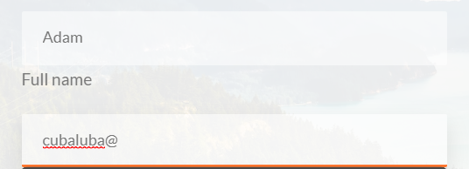

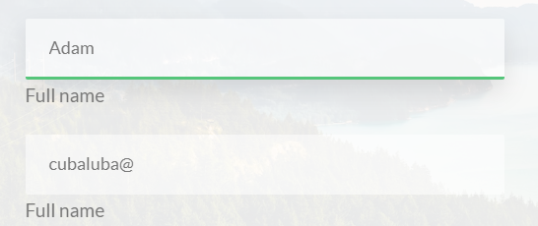

Note that your inputs have to have the **required** attribute for them to get validated by the browser: <input type=”email” required> 🡪 Makes the browser check if the input string is indeed a valid e-mail format.

## **Adjacent sibling selector(+) and general sibling-selector(~)**

Adjacent(the first sibling that comes **next**, **after** the selected non-pseudoclass element). It is important to note that sibling selectors only select the sibling that come after the first sibling element

firstSibling + secondSibling{…} or firstSibling ~ secondSibling{…}

 .input + .label {

  }

The adjacent sibling selector above selects all elements with the **.input** class, as well as their first next closest relative but only if that first relative has the **.label** class

In the case where the first **next** relative is not a label, but a button or another div, and we still want to select the closest lable sibling to our input element, we can still do this, using the general sibling selector **(~)**

.input ~ .label {

  }

That will select the first .label sibling, that comes **after** the .input element, no matter how many other sibling elements stand between the .input and .label

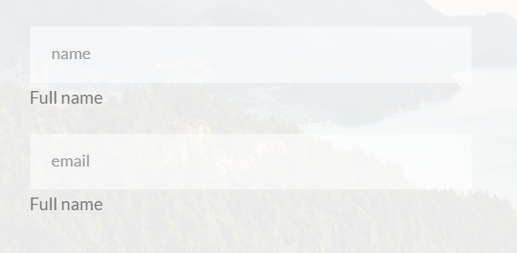To select the label in the form presented here, using the sibling selector, we would have to place the input as the first sibling, and **the label as the second sibling.**

### **:placeholder-shown** pseudo-class

This is a special pseudo-class that can be applied only to those elements that have a **placeholder** attribute defined in them. What it does is style the element in the state where its placeholder is showing. Ie, before the input element has any input characters in it, we may want it to display with a different size, font or color, then when the user is typing something in (and the placeholder is no longer showing)

### **Animating the label to appear as if it was moving down from the input element back to its normal position**

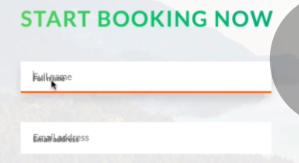**Here the label is shown in its newstarting position when the placeholder is also visible**

Basically what we want to do is set the label that is normally below our input element, to in it’s initial state be exactly where our placehodler text is (but the label would be invisible)

When the user types something inside the input and the placeholder is no longer visible, the :placeholder-shown state style declaration block would no longer be valid, and the label would return to its normal position under the label.

The transition between those two label styles that are connected via input placeholder states, would need to be animated to create a really cool effect, and to make that animation possible, we would have to set the element opacity to 0 (when the label is over the placeholder (so it would not appear as double text, visible in the example image above)

Note that visibility: hidden; 🡪 visibility:visible: cannot be animated!

Because of this we don’t only use visibility:hidden; property but also the opacity:0; property, which can be animated. So what happens is the opacity is animated from 100 to 0, then the element (label) gets hidden and disappears from the page layout.

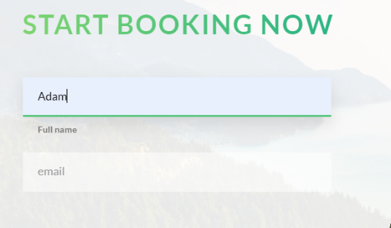

The code for the label animation

.input{

…

…

    &::-webkit-input-placeholder {

      color: $color-gray-dark-2;

    }

  }

  &__label {

    //The goal is to set the Label to be exactly under the placeholder text

    font-size: 1.2rem;

    font-weight: 700;

    //Display as block in order to enable the use of the margin properties

    display: block;

    margin-left: 2rem;

    margin-top: 0.7rem;

    transition: all 0.3s;

  }

  &__input:placeholder-shown + &__label {

    opacity: 0;

    visibility: hidden;

    transform: translateY(-4rem);//moves the element over the placeholder

  }

}

## **Styling a custom radio button**

The idea behind this is that you connect a radio input and a label

<input type=:”radio” id=”button>

<label from=”button”>

You give the label a cursor so the user knows to click it, and by default, a label connected to a checked box or a radio button, when clicked, puts the input element it is connected to, in a **:checked-state**

Knowing this, we instert a <span class=”radioButton:> inside the label, and leave the span element empty. We will style the span element into a shape we want our custom radio button to have.

To create the visuals of the custom radio button getting checked, we simply style the radioButton class span element’s 🡪 ::after pseudo element, so that it is a circle (or similar) shape, filling up the space inside our custom radio button, and is absolutely positioned relative to the Custom radio button element. After styling it, remembering to set it’s opacity to 0, as in a normal state our buttons are not checked, and so the checked custom button effect should not be visible

**Next-Making the ::after element visible, visually creating the checked state of our custom radioButton**

Then, when the user checks the radio-type input-element, by clicking on the label, we use a selector that modifies the style of the custom-button’s 🡪 ::after element, whenever the label is clicked, therefore putting the connected radio-input element in a checked state.

In other words, when the input is checked, the connected label’s span(customRadioButton)’s::after element gets an opacity of 1 (turns visible) and fills out the inside of our custom radio button.

After we’ve created the full effect and functionality of our custom radio button using its style and that of its ::after pseudo element, we can freely remove the visual display of our default radio-input radio button by passing a value to its display property making it into: **display:none;**

**-Hope this makes some sense. The code is in the following pages: 🡪**

### **Targeting the ::after pseudo element from our <span class=”form__radio-button”> custom radio button**

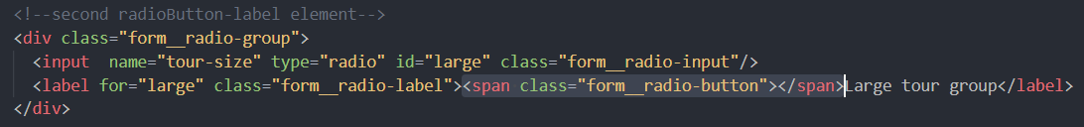

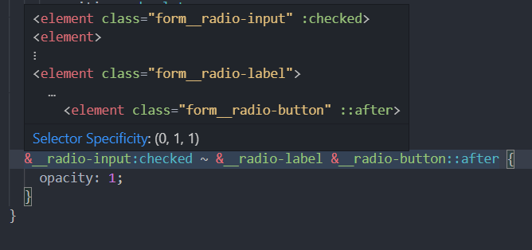

What the selector above does

1.Target the element with the **__radio-input** class that is in a **:checked** state

2. target the first **sibling** that you find with the class of **__radio-label**, of said checked element

3.Target the **siblings**(2.’s) child element with the class of **form__radio-button**

4.Then target its (3.’s) **::after** pseudo element

*Or in the reverse order:*

Target the **(1**)**afte**r pseudo element of an **(2**)element that has a class of **__radio-button** and is a child of an **(3)**element with the class **__radio-label** that has a **(4**)sibling in a (**checked** stateAnd a class of **__radio-input**)

Remember here, that you select child elements (most notably when you are familiar with their class name) from a parent element by ordering them one after the other without commas in this way:

**parent child grandchild greatGrandchild _||_ {…declarationBlock..;}**

**Just the code:**

 &__radio-group {

    width: 49%;

    display: inline-block;

  }

  &__radio-input {

    display: none; //Makes the default radio button disappear

  }

  &__radio-label {

    font-size: $default-font-size;

    cursor: pointer;

    position: relative;

    padding-left: 5rem;

  }

  &__radio-button {

    height: 3rem;

    width: 3rem;

    border: 5px solid $color-primary;

    border-radius: 50%;

    display: inline-block;

    position: absolute;

    left: 0;

    top: -0.4rem;

    //remember that for the pseudo element(after/before) to be visible

    //we have to define a content and display property value

    &::after {

      content: ""; //required

      display: block; //required

      height: 1rem;

      width: 1rem;

      border-radius: 50%;

      background: $color-primary;

      transition: opacity 0.2s;

      //Making it positioned exactly on the center of the parent

      position: absolute;

      top: 50%;

      left: 50%;

      transform: translate(-50%, -50%);

      opacity: 0;

    }

  }

  &__radio-input:checked ~ &__radio-label &__radio-button::after {

    opacity: 1;

  }

     <!--Radio Buttons-->

                <div class="form__group">

                  <!--first radioButton-label element-->

                  <div class="form__radio-group">

                    <input name="tour-size"  type="radio" id="small" class="form__radio-input" />

                    <label name="tour-size" for="small"  class="form__radio-label">

<span class="form__radio-button"></span>Small Tourgroup

</label >

                  </div>

                </div>

### Button elements on forms

When creating a form, we cannot simply use an anchor tag styled like a button <a class=”button”> element, because a form knows how to recognize and submit only <button> tags, so the anchor <a> tag disguised as a button would get ignored by the form.

## Making our utility classes always have priority

Sometimes our utility classes will not pass the cascade, and a more specific css rule declaration overwrites them. For utility classes, we always want them to have the highest priority, and make them always execute their declarations and styles wherever we place them.

To make this completely assured, we simply add !important to each utility declaration block. This is only a good practice for utility classes and absolutely nowhere else. Keep this in mind, and feel free to use **!Important** keyword, to bump your utilities to the highest importance, and so, priority ^^

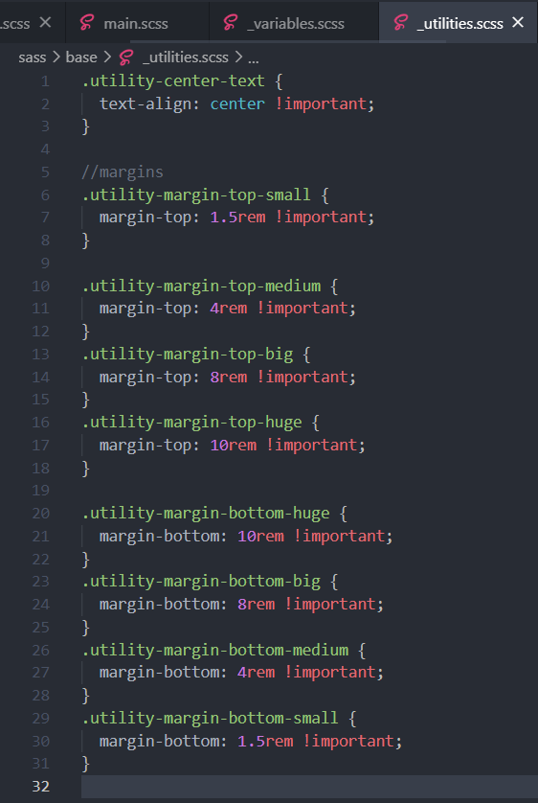

# Building a navigation

## What the “checkbox hack” is and how it works

### **Z-index(Revisited):**

Remember that it only ever works on elements that have a defined position property value. It may happen a lot that you want to place a larger Z index on an element that is showing behind something, and placing a higher Z-index simply does not help. Well In that case the problem was with the fact that your element did not have a position(absolute,relative, fixed,sticky…)set, honey….

## How to animate “solid-color gradients”

### 

### Animating links using a “solid color gradient” and background-size, background-position properties

On hover there appears a background change animation from right to left, changing the background color of the hovered or active element to white. In the following code, we will see exactly how to create this effect.

&__link {

    &:link,

    &:visited {

      display: inline-block; //Only now the padding will be applied

      //Also, only inline-blocks can have transforms applied to them

      font-size: 3rem;

      font-weight: 300;

      padding: 1rem 2rem;

      color: $color-white;

      text-decoration: none;

      text-transform: uppercase;

      background-image: linear-gradient(120deg, transparent 0%, transparent 50%, white 50%);

      background-size: 225%;

      transition: all 0.3s ease-in;

    }

    &:hover,

    &:active {

      background-position: 100%; //works just like translate on X-axis

      color: $color-primary;

      transform: translate(1rem);

    }

    //So the background behind the links is set to be two tone

    //using the solid color gradient. So the left side  of the background

    //image on our links is transparent and the right is white.

    //What we want to do is basically increase the size of the

    //background until the only the transparent parts are visible over

    //the links, and the white parts of the background are overflowing behind

    //the link elements, and so remain invisible.

    //Then, on hover, we want our background to move to the left,

    //in a way positioning the white part of the two tone background over our elements

    //and the way we do this is by using the "background-position: 100%;

    //property, which basically moves the background horizontaly by 100% of its elements width

    //Now our background was set to be 220% of the size of our link element

    //That meanst that background-position:100%; will be moving our actual background halfway to one side

    //The left side, to be precise. This means that now, the right-white side of the background

    //is over our links

    //To recap: 1.Two tone color our background using  solid color gradient (transparent, white)

    //2.Make the background twice as large as our links (background0size: 220%)

    //so that the colored part is outside of our link elements(invisible)

    //3.On hover Using the background-position property, move the background by a 100% of the width of the element

    //placing the white background now over our links

    //Animate the background-position transition, and voila, you have a working

    //animated background overlay effect

## How to create custom animation timing functions using cubic bezier curves

Basically go to this website [Easing Functions Cheat Sheet (easings.net)](https://easings.net/)

And choose the most appropriate animation timing function, by copying the coordinates for their cubic bezier curves (just click on them basically)

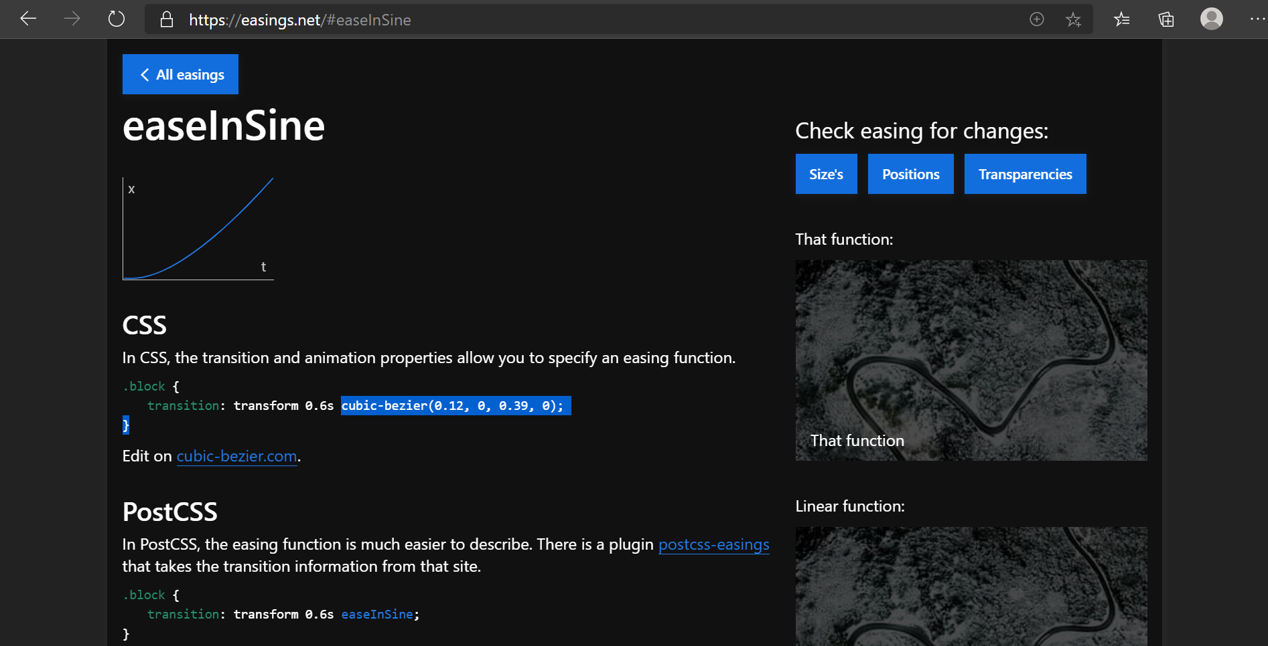

## Creating the animation for our nav element

Basicailly what we have here is a circle(green background) behind a circle(of a white background), with the exception that the navigation button has an absolutely positioned navigation background behind it, both are a circle, but the navigation background is a slightly smaller circle positioned right underneath the white nav—button.

When we click the nav button(which is basically a label connected to a checkbox) the checkbox changes into a checked state, and for that checked state, we have created a style that basically scales up the green background nav background 80 times scale(80) so that it completely covers the viewport, and maintaining a fixed position we’ve previously given it, stay on the viewport until the check box is in an un-checked state.

Because the background is a circle (same width, height and a border-radius of 50%) scaling it up, from behind the nav button, creates the illusion of the circle expanding from underneath the nav button and over the screen, (the nav stays visible because it has a z-index larger than the background) The nav list elements have a z index larger than the background as well, and the background has a z-index larger than any other element on the page, save the nav button and list. So that it always overlays

**Note that the label connected to the now invisible checkbox on whose checked state we style the nav__background is basically styled into the white button on the right corner and given a class of nav__button. So the label connected to the checkbox is visually our navigation button**

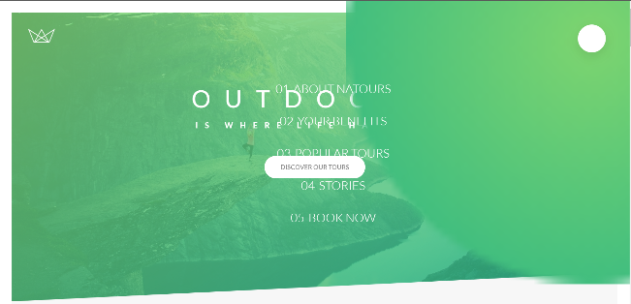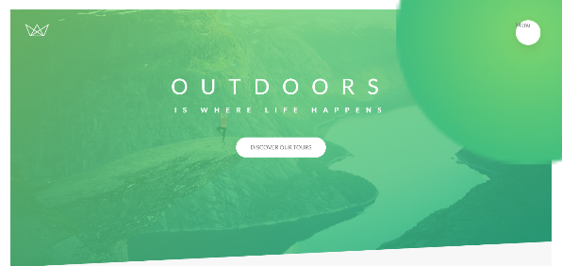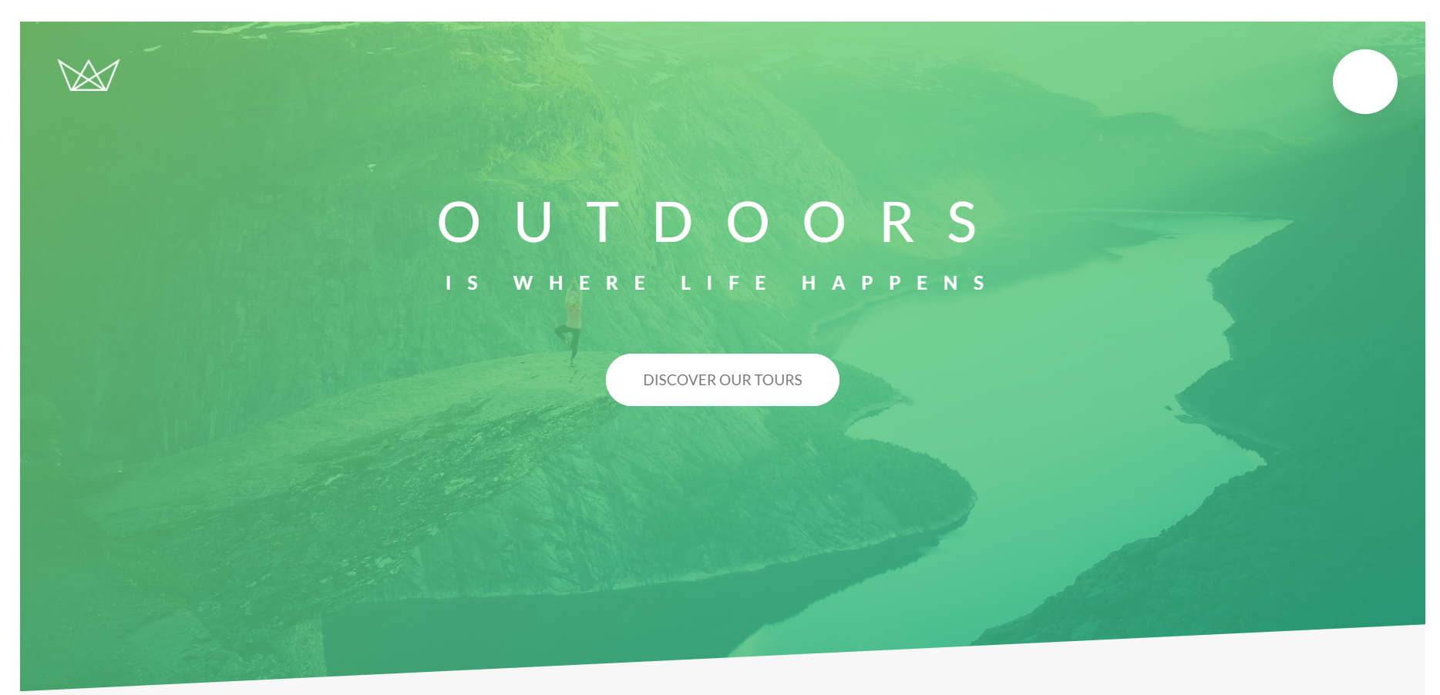

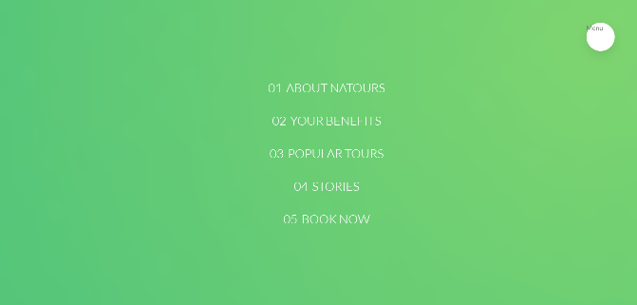

.navigation {

  &__checkbox {

    display: none; //hiding the default checkbox

  }

  &__button {

    background-color: $color-white;

    //We are making the button larger than the background in order

    // to make the background not show (peek) behind it.

    height: 7rem;

    width: 7rem;

    position: fixed;

    top: 6rem;

    right: 6rem;

    border-radius: 50%;

    box-shadow: 0 1rem 3rem rgba($color-black, 0.1);

    z-index: 2000; //higher z-index to go over its background

  }

  //Styling the circular background of our nav-bar toggle button

  &__background {

    height: 6rem;

    width: 6rem;

    border-radius: 50%;

    position: fixed;

    top: 6.5rem;

    right: 6.5rem;

    background-image: radial-gradient($color-primary-light, $color-primary-dark);

    z-index: 1000; //Works only on elements that have a defined position

    transition: all 10s cubic-bezier(0.83, 0, 0.17, 1); //ANIMATION

    //transform: scale(80); //placehodler location

  }

  //Nav contains our list with nav bar clickable links

  &__nav {

    height: 100vh; //100% of the viewport (if it was 100% it would mean of the parent)

    //positioning the nav over the entire screen

    position: fixed; //makes the nav always display on screen

    //Make the element start at the begining of the screen

    top: 0;

    left: 0;

    z-index: 1500;

    //More visible than the background, less visible than the button

    //So the button background is hidden, but the button is visible in the nav

    //--Setting the initial state to the background to disappear

    opacity: 0; //this makes the elements invisible but clickable and still on screen

    width: 0; //this removes the nav elements from the screen completely

    transition: all 10s cubic-bezier(0.34, 1.56, 0.64, 1);

  }

  &__list {

    //centering the list inside the nav container

    position: absolute;

    top: 50%;

    left: 50%;

    transform: translate(-50%, -50%);

    list-style: none;

    text-align: center;

    width: 100%;

  }

  &__item {

    margin: 1rem;

  }

  &__link {

    &:link,

    &:visited {

      display: inline-block; //Only now the padding will be applied

      //Also, only inline-blocks can have transforms applied to them

      font-size: 3rem;

      font-weight: 300;

      padding: 1rem 2rem;

      color: $color-white;

      text-decoration: none;

      text-transform: uppercase;

      background-image: linear-gradient(120deg, transparent 0%, transparent 50%, white 50%);

      background-size: 225%;

      transition: all 0.3s ease-in;

    }

    &:hover,

    &:active {

      background-position: 100%; //works just like translate on X-axis

      color: $color-primary;

      transform: translate(1rem);

    }

    span {

      display: inline-block;

      margin-right: 1rem;

    }

  }

  //The checkbox hack

  //Using the label linked to the checkbox to check/uncheck the now invisible checkbox

  //So that we can, based on the checkbox state(modified by clicking the label)

  //change the style of the element(in this case, the nav menu button, and display of the nav

  //when the checkbox is checked

  //If the checkbox is checked, select the background sibling and apply these rules

  &__checkbox:checked ~ &__background {

    transform: scale(80); //displays the nav background overlay over the whole viewport

  }

  &__checkbox:checked ~ &__nav {

    //Displays the nav elements(links)

    opacity: 1; //makes them visible

    width: 100%; //makes them have their full default clickable size

  }

}

<div class="navigation">

      <input type="checkbox" id="navi-toggle" class="navigation__checkbox" />

      <label for="navi-toggle" class="navigation__button"></label>

      <div class="navigation__background">&nbsp;</div>

      <nav class="navigation__nav">

        <ul class="navigation__list">

          <li class="navigation__item">

            <a href="#" class="navigation__link"><span>01</span>About Natours</a>

          </li>

          <li class="navigation__item">

            <a href="#" class="navigation__link"><span>02</span>Your benefits</a>

          </li>

          <li class="navigation__item">

            <a href="#" class="navigation__link"><span>03</span>Popular tours</a>

          </li>

          <li class="navigation__item">

            <a href="#" class="navigation__link"><span>04</span>Stories</a>

          </li>

          <li class="navigation__item">

            <a href="#" class="navigation__link"><span>05</span>Book now</a>

          </li>

        </ul>

  </nav>

 </div>

## How and why to use transform-origin

When used for, let’s say, transform: rotate(45deg). The element will by default rotate 40deg around its center. But sometimes we want our elements to rotate like doors rotate, or a windowsil would, for some clickable elements, creating the illusion of oppening a door or a window to view the content inside.

For these effects, we cannot simply rotate a door from its center. We must rotate it relative to the side it is hinged on. This is where transform origin becomes useful

**Transform-origin: left;**

**Transform-origin: right;**

**Transform-origin: top;**

**Transform-origin: bottom;**

We place this property on the element doing the transformation, and it will, depending on the passed value, for a (rotate-transform) rotate from the: left, right, top or bottom. Making an animation that would otherwise only be possible by rotating a half transparent element, half colored element down the middle (as is the default way rotation works)

## Creating the three-bar animated nav-icon



Basically the three bars separate further on hover, and when the nav menu opens (the button is checked) the top two bars criss cross in an icredibly cool and spiffy animation, and the middle bar dissappears by becoming transparent.

This effect seems pretty straightforward, though there are some 100lines of code required to make this happen. Namely The middle bar is a an empty <span “nav__icon”> element with a ::before and ::after pseudo elements styled to look exactly like it does(making them together into three bars). That span (icon) element is placed inside the nav__button <label> element and so is easily positioned on the button using absolute positioning, also, that parent <label nav__button) is connected to the nav__checkbox. When the checkbox is checked we transform the three bars from paralel to an X. by rotating the top ::before and bottom ::after element 40degrees relative their current position, and making the middle element transparent.

Remember that when you work with pseudo element, display:non of their non-pseudo parent, or width/height/position changes, affect the pseudo elements as well.

WhenThis animation is mainly free spirited experimentation until the effect is just right. Try out the code below, and you’ll see how cool it turns out.

  //##NAVIGATION ICON###

  &__icon {

    position: relative;

    margin-top: 3.5rem;

    //Defining the shared style between

    //the icon line and it's before/after pseudo elements

    &,

    &::before,

    &::after {

      z-index: 50000;

      width: 3rem;

      height: 2.5px; //we don't want the height of our nav lines ever to change

      background-color: $color-gray-dark-3;

      display: inline-block; //we want them all to display as inline blocks

    }

    //Defining the shared position property between pseudo-lines

    &::before,

    &::after {

      content: ""; //content needs to be defined for the two pseudo lines

      position: absolute;

      display: inline-block;

      left: 0;

      transition: all 0.2s;

    }

    //positioning the top pseudo line

    &::before {

      top: -0.8rem;  //moving it above the reference icon-line

    }

    &::after {

      bottom: -0.8rem; //moving it below the reference icon-line

    }

  }

  &__button:hover &__icon::before {//This simple selector is possible because the icon is a child elementof the button

    top: -1rem;

  }

  &__button:hover &__icon::after {

    bottom: -1rem;

  }

  //If the box is checked get the button sibling and target it's child-icon's after element

  &__checkbox:checked ~ &__button &__icon::after {

    transform: rotate(220deg);

    //We want them to rotate 40deg from where they are

    //But before they stop at the 40deg angle, we want them to rotate 180deg

    //So it looks super flashy!

    top: 0;

    bottom: 0; }

  &__checkbox:checked ~ &__button &__icon::before {

    transform: rotate(-220deg);

    top: 0;

    bottom: 0;

  }

  &__checkbox:checked ~ &__button &__icon {

    background-color: transparent;   //If we change the size or position of this icon element

    //we will also change the size of the before and after elements

    //We don't want to do that, as that complicates things

    //So instead of changing the icon element, we simply make it disappear

    //by turning it transparent

  }

}

 <div class="navigation">

      <input type="checkbox" id="navi-toggle" class="navigation__checkbox" />

      <label for="navi-toggle" class="navigation__button">

        <span class="navigation__icon">&nbsp;</span>

      </label>

## VERY IMPORTANT REMINDER FOR SIZING YOUR CONTAINERS

Remember that you should only ever define the container width, the height should be left at the default AUTO, so that your containers by themselves adjust to the size of the content placed inside them. For testing purposes, initially, create a container width AND HEIGHT, but remember to delete the Height, or set it to auto, as soon as you start placing elements into your div/containers. I cannot stress this enough, as the initial problem of your container squashing your elements, or being too big for the elements fit into it, always lies in the fact that you may have defined the size to plastically.

Set either only the height, or the width (depending on the type of container you want to have (high column or wide row). They should be exclusively specified, and never together at the same time for the same container. (rules are meant to be broken, but this is a very generally advised and adhered to, rule of thumb.)

Width: 100%; height: auto;//cool

Height:100%; width: auto; //cool

Height:100% width:50%; //not cool dawg (or initial development purpose before inserting elements)

## How to build a nice popup with only CSS

## How to create boxes with equal height using display:table-cell;



Basically, when we have a box where we wish to have two divs of the same height, what we can do to make the browser do just that implicitly is to set the parent box to **display:table;** and the child div elements to **display:table-cell;** making them a cell within a table element. Doing so will make the browser automatically assign them the same height, so we don’t have to fiddle a lot doing that manually.

 Parent.{

 display: table;

  }

  &__left {

    width: 33.333333333%;  //1 third of the container

    display: table-cell;

  }

  &__right { //2 thirds of the container

    width: 66.6666666667%; //To make the left and right element roughly 100%

    display: table-cell;

    vertical-align: middle;

  }

  &__img {

    display: block;

    width: 100%; //makes them the parent container width

  }

  &__text {

    width: 100%;

    display: inline-block;

  }

Hot to use the :target pseudo-class;

## How to create CSS text columns

    //Creating text columns

.text-container{

    column-count: 2;

    column-gap: 4rem; //default 1em --> font size of the current element

    column-rule: 1px solid $color-gray-2;

}

**Column-count 🡪** how many columns we want to separate our text into

**Column-gap 🡪** how large the space between the column should be

**Column-rule 🡪** The line between the columns (optional) color and style (just like a border)

## How to automatically hyphenate words using hyphens

It is a pretty modern/relatively new tool (as of 2017) so it needs plenty of prefixes in order to work on all modern browsers.

**hyphens: auto;**

Automatically sets the hipyhens (text-break lines) whenever a word breaks into a new line, just note that for hyphenating to work properly, you actually have to define a language for the website (so your browser recognizes the words it is supposed to hyphen)

<html lang="en">

English if you wish to hyphenate english, and Serbian or other language, if you want your browser to hyphenate text in another language. Note how Column rules and hyphen rules are relatively new, so we need to use prefixes to make them work in all browsers

   -moz-column-count: 2;

    -moz-column-gap: 4rem; //default 1em --> font size of the current element

    -moz-column-rule: 1px solid $color-gray-2;

    -ms-hyphens: auto; //ms explorer - or ms edge

    -moz-hyphens: auto;

    -webkit-hyphens: auto; //chrome and safari

## Opening our pop-up using anchoring

Basically, we can create ID’s for elements, and then have our <a> tags (anchors) have in their href=attribute the #+Id-value, so that on click, that anchor transports us to the target element.

In other words, you can imagine, that one element can throw it’s ID as an anchor, to many <a> elements, anchors if you will. (Those <a> element anchors are all connected to that single element, called **the target element**

By using <a class=”button”> anchor tags targeting our pop-out window, we can make the window appear/disappear on the click of the anchor button. This is why we generally use anchors as buttons instead of using buttons, as they have the ability anchor and return us to their target elements using the passed element ID contained in their href attribute.

### **Making the pop-up element invisible**

**Display:none;**  is not the best way to make elements that we want to reappear, disappear, because we simply cannot animate **display** property. We can only animate(transition) porperties that have values passed to them, more specifically numbers of units.Those units can be animated, as they represent iterating increments from current state to target state, and making the transition between the two visible.

In short

WE CANNOT ANIMATE THE DISPLAY PROPERTY SO WE MAKE OUR ELEMENT DISSAPEAR DIFFERENTLY

The solution:

  //making the element hidden until button clicked

    opacity:0;

    visibility: hidden;

opacity is for animating

visibility: hidden; makes the element dissappear from the normal page flow, so that it cannot be clicked or stop us from clicking elements it is overlayed over.

**Anchoring our popup**

<a href="#popup" class="btn btn--white">Book now!</a>

.popup {

  position: fixed;

  top: 0;

  left: 0;

  height: 100vh;

  width: 100vw;

  background-color: rgba($color-black, 0.8);

  z-index: 5000;

  //making the element hidden until button clicked

  opacity: 0;

  visibility: hidden;

  //Animating the popup

  transition: all 0.5s;

  //.popup:target

  &:target {

    opacity: 1;

    visibility: visible;

  }

}

So how anchoring our popup works is that we want our popup style (that makes the popup visible) to take over when the popup itself is the target of a link click. So what happens is that we click on the link, and as our popup element becomes the target of the link and the element’s **:target** state is active the popup appears (its visibility and opacity are turned back on(off in the regular element state).

Now there is only ever one target at a time, in the browser, so each time we press a link the browser sets the target state to a new element. So the way we make the popup disappear is to simply make the **:target** state styles no longer valid for said element. The target state for our popup is not going to be valid (it will be no longer set on the popup element) the moment we follow another link by pressing an anchor tag <a> that is anchored to another element, since that gives the tag’s anchor element the current **:target** state, making our **.popup** element no longer a target, and so, the **:target** rules declared for the **popup** element no longer apply to it. In this case, making any other element a target makes our popup disappear, as it only appears (is set to become visible) if it is a target.

In our popup window, we have set a .popup__close <a> element, and given it the anchor href value to reference the ID of the TOURS section. This changes the target element to #tours, so the #popup is no longer target, and this makes our popup no longer visible.

### What to do if you need to implement two transforms on a single element?

You well know that an element may only have one transform property at a time. Well, you can delcare as many as you want, but only one will get calculated as it wins out in the cascade.

Sometimes (basically when we use mixins and xtends) it happens that we cannot simply add a new transform value to our original transform, because changing the mixin will change it for all elements that implement that mixin.

What we have to do in that case, is copy the exact transform poperty values that we’ve already had, and add our desired new value, and place that at the bottom of the css/sass declaration block for that element. That way, only the last transform rule will get calculated, and that will be okay, because we placed all of the same values from our previous transform(so it will act in the same way) plus added a new value, that we wanted to additionally implement.

&__content {

    @include absCenter; //Absolute center mixin:

    //position: absolute;

    //top: 50%;

   // left: 50%;

// transform: translate(-50%, -50%);

    width: 75%;

    background-color: $color-white;

    box-shadow: 0 2rem 4rem rgba($color-black, 0.2);

    z-index: 5500; //has to have a larger index than dark background

    border-radius: 3px;

    //making the images not overflow over our border radius

    overflow: hidden;

    //Making the container act as a table

    //and children containers act as cell

    display: table;

    //Defining the initial (un-poped state) of our popup content card

    opacity: 0;

    transform: translate(-50%, -50%) scale(0.5);

//repeating the original transform and adding to it a scale value

  }

### **Creating the pop-up animation for our popoup box container**

## Complete Code for the CSS popup window

.popup {

  position: fixed;

  top: 0;

  left: 0;

  height: 100vh;

  width: 100vw;

  background-color: rgba($color-black, 0.8);

  z-index: 5000;

  //Making the element hidden before it pops up

  opacity: 0;

  visibility: hidden;

  //Animating the popup

  transition: all 0.5s;

  &__content {

    @include absCenter; //Absolute center mixin

    position: absolute;

    top: 50%;

    left: 50%;

    transform: translate(-50%, -50%);

    width: 75%;

    background-color: $color-white;

    box-shadow: 0 2rem 4rem rgba($color-black, 0.2);

    z-index: 5500; //has to have a larger index than dark background

    border-radius: 3px;

    //making the images not overflow over our border radius

    overflow: hidden;

    //Making the container act as a table

    //and children containers act as cell

    display: table;

    //Defining the initial (un-poped state) of our popup content card

    opacity: 0;

    transform: translate(-50%, -50%) scale(0.25);

    transition: all 0.5s 0.2s; //added .2s delay

    //so overlay first appears, then our element starts working

  }

  //1 third of the container

  &__left {

    width: 33.333333333%;

    display: table-cell;

  }

  //2 thirds of the container

  &__right {

    width: 66.6666666667%; //To make the left and right element roughly 100%

    display: table-cell;

    vertical-align: middle;

    padding: 3rem 5rem;

  }

  &__img {

    display: block;

    width: 100%; //makes them the parent container width

  }

  &__text {

    font-size: 1.4rem;

    margin-bottom: 4rem;

    //Creating text columns

    -moz-column-count: 2;

    -moz-column-gap: 4rem; //default 1em --> font size of the current element

    -moz-column-rule: 1px solid $color-gray-dark-2;

    -ms-hyphens: auto; //ms explorer - or ms edge

    -moz-hyphens: auto;

    -webkit-hyphens: auto; //chrome and safari

    //automatically sets the hipyhens (text-break lines) whenever a word breaks into a new line

  }

  //DEFINING THE POPUP - OPEN states

  //.popup:target

  &:target {

    opacity: 1;

    visibility: visible;

  }

  //Animating the content child element of the child element

  //so that it pops out to the screen when the popup becomes the target

  &:target &__content {

    opacity: 1;

    transform: translate(-50%, -50%) scale(1);

    //Making sure to keep the translate values from our mixin

  }

  //CLOSE BUTTON

  &__close {

    &:visited,

    &:link {

      color: $color-gray-dark;

      position: absolute;

      top: 2.5rem;

      right: 2.5rem;

      font-size: 3rem;

      text-decoration: none;

      display: inline-block;

      transition: all 0.2s;

      line-height: 1;

      &:hover {

        color: $color-primary;

      }

    }

  }

}

 <!--##POPUP##-->

    <!--Dark popup bakround-->

    <div class="popup" id="popup">

      <!--Content Box-->

      <div class="popup__content">

        <!--Left popup element-->

        <div class="popup__left">

          <img class="popup__img" src="images/nat-8.jpg" alt="Tour Photo" />

          <img class="popup__img" src="images/nat-9.jpg" alt="Tour Photo" />

        </div>

        <!--Right popup element-->

        <div class="popup__right">

          <!--Close button-->

          <a href="#section-tours" class="popup__close">&times;</a>

          <h2 class="heading-secondary utility-margin-bottom-smalll">Start booking now</h2>

          <h3 class="heading-tertiary utility-margin-bottom-small">Important &ndash; Please read these terms before booking</h3>

          <p class="popup__text">

            Lorem ipsum dolor sit, temporibus optio quos rerum? Quidem harum sunt inventore perspiciatis.amet consectetur adipisicing elit. Inventore,

            maiores sed nesciunt exercitationem quam explicabo magnam earum aspernatur dicta nulla consectetur odit quos officiis

            consequatur,temporibus optio quos rerum? Quidem harum sunt inventore perspiciatis. necessitatibus ea pariatur veniam voluptatibus. Lorem,

            ipsum dolor sit amet consectetur adipisicing elit. Est doloribus autem beatae cumque aut provident earum cupiditate, voluptatibus porro,

            perspiciatis ad temporibus optio quos rerum? Quidem harum sunt inventore perspiciatis.

          </p>

          <a href="#" class="btn btn--green">Book now</a>

        </div>

      </div>

    </div>

### **The final popup look ^_____^**

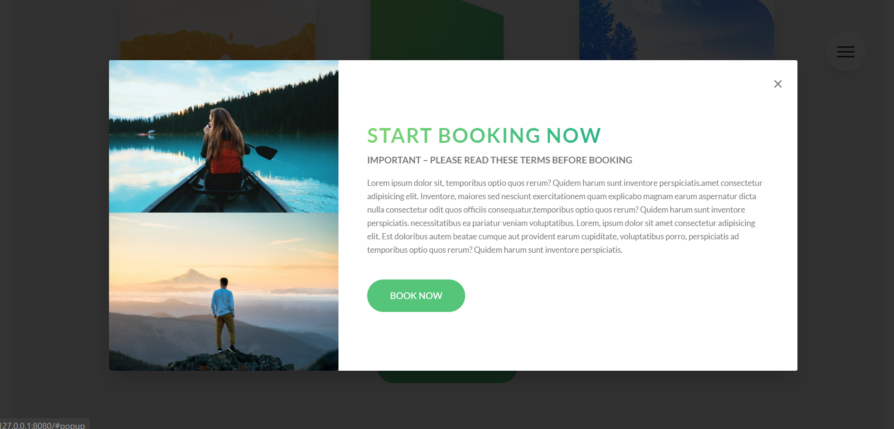

# Responsive Design Strategies

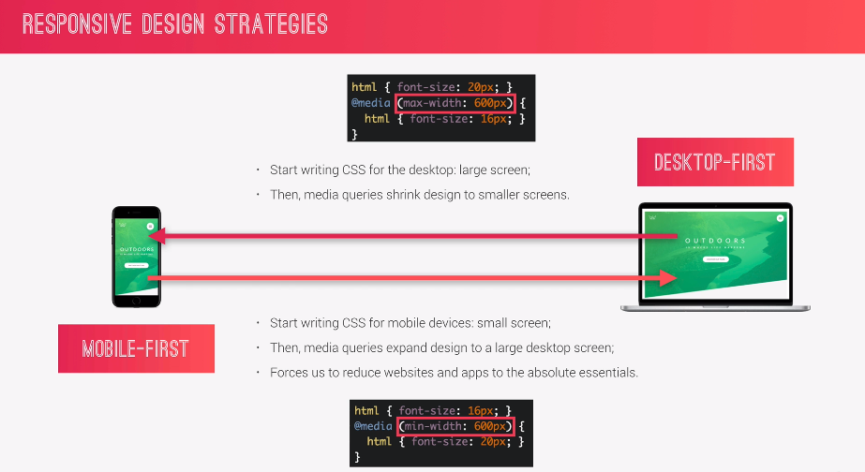

Remember that media queries don’t add importance or specificity to selectors, so the **code order matters** as that is the only way in which we can control which rules have precedence(priority). What you need to know for creating various media quey breakpoints, is that they will usually contain conflicting CSS, the least of which will be the font-size, or differently defined percentage of the REM html font size.

This means that rarely will you ever have all of the css from all the breakpoints complement each other, as they are by their nature conflicting (this or that, mobile or tablet, very rarely is there a common style for mobile AND tablet, if there is a breakpoint created between those two viewport sizes).

## Desktop first

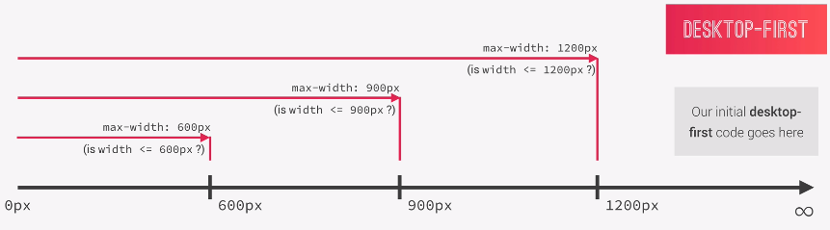

On the picture we see thresholds as they are defined for a desktop first approach. Our default(desktop version) is the 1200px 🡪 infinity, where there are no media queries applied. And at the threshold of max-width:1200px we have the first media query, remembering that all media queries for the max-width:1200px apply on all elements from 0px to 1200px.

Next we see that the max width 900px media query applies for all devices from 0px to 900px, and the media query at 600px max width, applies for all devices from 0px to 600px.

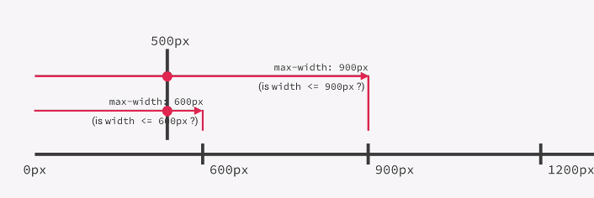

If our device is 500px for example, let’s check which media queries apply.

500px < 600px 🡪true (so the first 600px max width media query applies)

500px < 900px 🡪 true (so the second 900px max-width media query also applies)

**500px < 600px && 500px < 900px 🡪True (so both queries apply)**

In pseudo-code

**forEach(mediaQuery in MediaQueries)**

**if(device.devficeWidth< mediaQuery.maxWidth)**

**device.classList.add(mediaQuery.classList[0]);**

## Mobile first

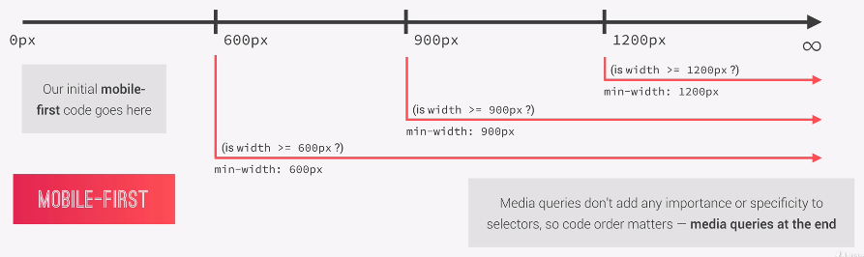

## Is mobile first right for you?

## Using breakpoints

Different ways of choosing breakpoints px points

* **Bad way** of choosing breakpoints: Choosing specific device-sizes of a specific manufacturer
* **Good way**: finding the average for more types and most popular devices, of a device size, so you find many popular phone, tablet, laptop screen sizes, group them by device, and calculate the average scren size for each device group. The groups average screen size is your breakpoint for said device type(phone, tablet, laptop, etc…)
* 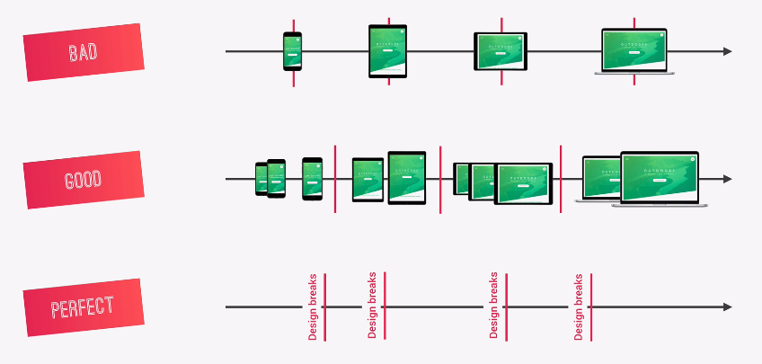 **Perferct way** By setting threhsolds relative to your website content, in other words, if you develop desktop first, you complete your prototype, then you start shrinking your browser, and as soon as your initial design breaks, you set a break point and add a media query to fix it. Then after you set up your first break point, you start shrinking again, and again, as soon as your browser becomes small enough to break your content, you add another breakpoint and write a new media query. You keep doing this until you can completely or reasonably shrink the browser, with the content not breaking at any browser size. This completely future-proofs your design, and is completely independent from device screen types. It will always work and always look great! **This approach is very difficult and requires a lot of work. And that is why it is rarely used.**

## The good way of selecting breakpoints

Basically, since the perfect way requires a lot of work, most developers choose to find an average width for each device type and work by referencing those data as their media query breakpoints.

A great place to find the device statistics (device width grouped by type and ordered by popularity) is to use the **StatCounter(global stats)** website’s screen resolution stats:

[Screen Resolution Stats Worldwide | StatCounter Global Stats](https://gs.statcounter.com/screen-resolution-stats)

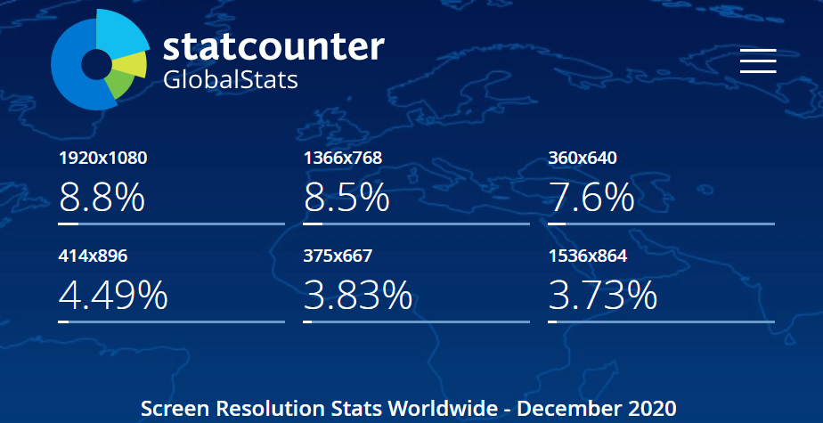

How we categorize breakpoints

Usually we have a breakpoint for each device type, so breakpoints are created as follows:

* One breakpoint for phones
* One breakpoint for portrait tablets
* One breakpoint for landscape tablets
* One breakpoint for the desktop

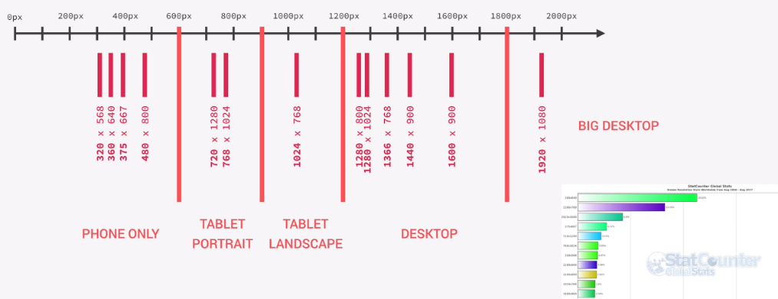You can of course add more breakpoints, but in general, this can be considered to display well on most devices that are going to be accessing your website.

## The best way of writing media queries in SASS

//HOW the **@content** declaration block parameter works

@mixin respond-phone {

  @media (max-width: 600px) {

    @content;

    @content Whatever the user writes inside the mixin body

  }

}

 When we includes the mixin, in the following way

**@include respond-phone{font-size: 12px; color:black; …}**

The content keyword of our mixin accepts the following:

**@content = {font-size:12px; color:black; …},** just like a parameter accepting an object/structure

**@content** basically works like a parameter that instead of an argument

        accepts a declaration block of css key-value rule statements { key: value;}

//MEDIA QUERY MANAGER

//0 -600px:  Phone

//600-900px: Tablet portrait

//900-1200px: Tablet landscape

//[1200- 1800] is where our normal styles apply

// 1800px +: Big desktop

/*

   $breakpoint argument choices:

   - phone

   - tab-port

   - tab-land

   - big-desktop

  */

@mixin respond($breakpoint) {  //Our mixin manager checks what breakpoint parametertext is included

//and applies only the mixin contentthat corresponds to one of the four available breakpoints

  @if $breakpoint == phone {

    @media (max-width: 60rem) {

      //less than 600px

      @content;

    }

  }

  @if $breakpoint == tab-port {

    @media (max-width: 900px) {

      //less than 900px

      @content;

    }

  }

  @if $breakpoint == tab-land {

    @media (max-width: 1200px) {

      //less than 1200px

      @content;

    }

  }

  @if $breakpoint == big-desktop {

    @media (min-width: 1800px) {

      //1800px or more

      @content;

    }

  }

}

### **Converting breakpoint min/max-widths from px to em**

The people who design sass, figured out that while media queries always treat em or rem as being a unit of 16px, **em** are less troubleshoot prone than their rem counterparts, so when converting breakpoints into relative units, the best practice is to indeed use **em** instead of rem.

Remembering the fact that the media queries disregard what percentage of root font-size we’ve defined in the html tag, and always treats rems and em’s as units of 16px, we will begin to convert our breakpoints defined in px(since we initially made them to reference device-pixel-widths) to em’s. The way this is done is by simply dividing our current px device-width by 16, and then adding **em** at the end.

**Conversion in practice:**

**600px / 16 = 37.5em**

### **Why convert breakpooint pixels to relative units**

Simply because the user may opt to change the zoom on his device. Initially 1:1 is 1rem = 16px, if the user zooms in twice as much, one rem will become 32px, but our px media query will not adapt to the new value, it will simply treat the device as being twice as large, so we want our media queries to adapt to the user changing the root font size, so that when the font size changes(the user zooms in), our breakpoint defined thresholds get larger instead of remaining the same. Meaning that no new media queries will be applied when the user changes font size, but only when the user changes device or resizes the browser on desktops.

@mixin respond($breakpoint) {

  //Our mixin manager checks what breakpoint parameter

  //text is included, and applies only the mixin content

  //that corresponds to one of the four available breakpoints

  //Device with (px) converted to em by dividing px-value /16

  @if $breakpoint == phone {

    @media (max-width: 37.5em) {

      //apply on devices lesserless than 600px

      @content;

    }

  }

  @if $breakpoint == tab-port {

    @media (max-width: 56.25em) {

      //apply on devices lesserless than 900px

      @content;

    }

  }

  @if $breakpoint == tab-land {

    @media (max-width: 75em) {

      //apply on devices lesser than 1200px

      @content;

    }

  }

  @if $breakpoint == big-desktop {

    @media (min-width: 112.5em) {

      // apply on devices  of 1800px or more

      @content;

    }

  }

}

### **Scaling the relative font-size using media query mixin**

Remembering how we defined the root font size using a percentage, so that we could bascially size all of our elements in relative units of (rem). Well, this means that if we change the value of the root font size, all of our elements will scale according to that root value. (50% of the original root font size) will make all of our elements defined in the relative unit of the root font size scale 50% down.

This makes your life when writing media queries so much easier, as you are not only redefining the root font sizes for various device widths, but at the same time scaling all of the elements in the webpage defined by (rem).

This is exactly the reason why it is such a good practice to first define the root font size in a relative percentage (usually 10px so converting to rem is easy as moving the decimal one position to the left.) so that we can use rem units throughout our webiste.

/*Performing the basic reset*/

html {

  //This defines what 1rem is

  //if 1rem = 10px then the percentage of 16px(100%)

  //is (100/16)*100 = 62.5%

  font-size: 62.5%; /*62.5% of ( 100% == 16px) is 10px */

  @include respond(tab-land) {

    //width < 900px

    font-size: 56.25%; //we want 1rem  to be 9px   (9/16px)*100 = 56.25%

  }

  @include respond(tab-port) {

    //width<600px

    font-size: 50%; //we want 1rem = 8px   (8/16px)*100 = 50%

  }

  @include respond(big-desktop) {

    font-size: 75%; //we want 1rem to be 12px (12/17)*100 = 75%

  }

}

### **Writing media queries in the correct order**

Remember the order of placing media queries, as their priority in the cascade is only dictated by the order they are written in (in the case two media queries conflict)

**Desktop-first:**

So when including the media queries using **max-width** always include those with the bigger max-width on top, smaller max width on the bottom remembering to leave the last min-width (big-desktop) media query on the bottom

**Mobile-first:**

And when including media queries using min-width everything should be done the other way around. The bigger min-width should go to the bottom. Making sure the max-width for the 0-600px is at the very top,

## Creating responsive layout elements

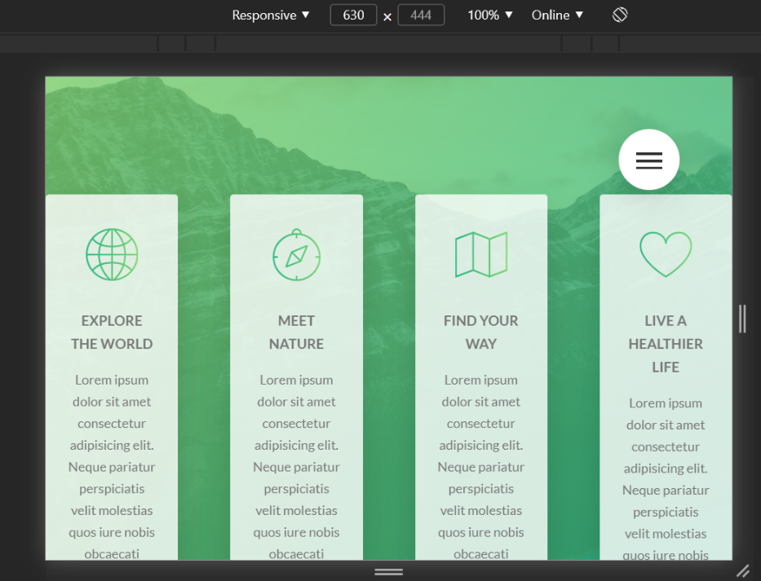

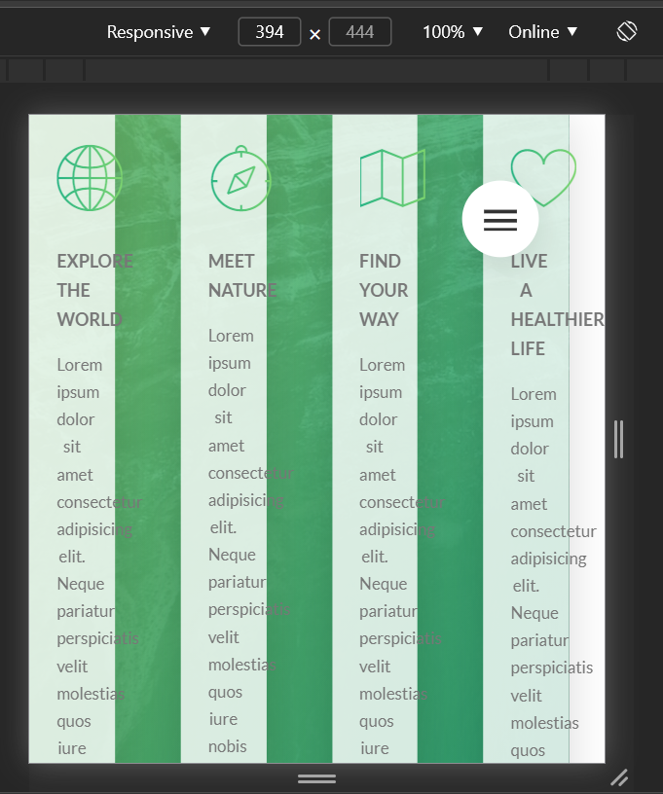

For the natours project, we’ve used a floating-grid layout system, creating rows in our sections and inserting elements into the row’s columns. Above we can see a row with four column-1-of-4. Representing a row with four columns, where each column is the same size.

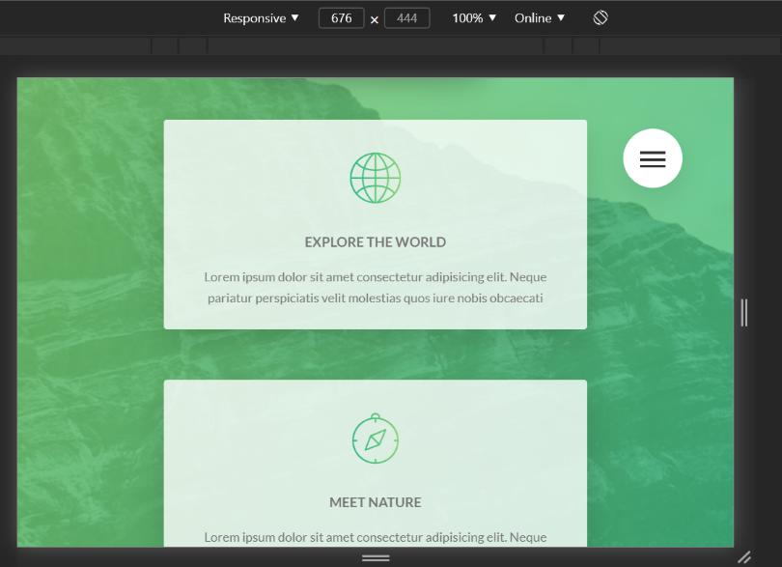I don’t have to say that we don’t want to have our elements (their column containers actually) squashed up like this. So how this situation is usually fixed in our layout elements is by simply giving each column a width of 100%. So that means that the column get’s a width of 100% of its parent row, meaning that we’ve essentially turned our columns into rows. So a row of columns would in this case become a row of four rows stacked on top of each other.

On the right is our desired layout for smaller screens. 🡪

**Let’s see how this looks in practice:**

.row {

  max-width: $grid-width; /*1140px*/

  margin: 0 auto; /*trick to center one block element inside another block element*/

  //Setting up the gutter between the rows

  &:not(:last-child) {

    margin-bottom: $gutter-horizontal;

    //Media query

    @include respond(tab-port) {

      margin-bottom: $gutter-horizontal-small;

    }

  }

  //Media query (making the elements not spread out over all avaliable space

  // when max-width is not reached, by making the max width smaller

  @include respond(tab-port) {

    max-width: 50rem;

  }

  //Insert clearfix before our columns

  @include clearfix; //.row::after{clearfix-content}

  //ATTRIBUTE SELECTOR sellects all columns, floats them and

  //adds a right margin(gutter) to all but the last column

  [class^="column-"] {

    float: left;

    //Setting up the gutter between the columns

    //gives a margin-right to all columns except the last(child)one

    &:not(:last-child) {

      margin-right: $gutter-vertical;

      //Media query

      @include respond(tab-port) {

        margin-right: 0;

        margin-bottom: $gutter-horizontal-small;

      }

    }

    //MediaQuery

    @include respond(tab-port) {

      width: 100% !important; //column becomes as wide as it's parent row(turns into row)

      //has to be important to make sure the more specific

      //column width rules that follow don't overwrite this media query

    }

  }

### **Before adding changing max-width in a media query vs after**

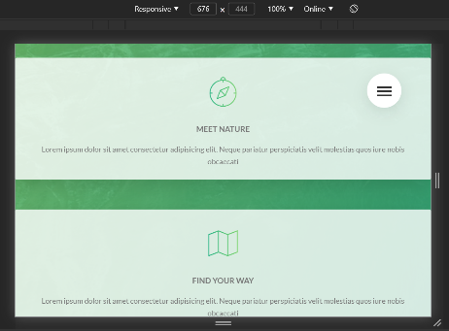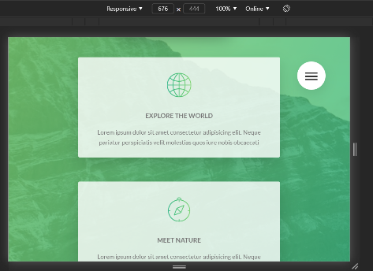Max width works in the following manner, if our viewport is smaller than the set max-width, the element will take up as much space as is currently available in the viewport.

On the other hand, If the viewport is larger then the set max-width of the element, it will remain at the max-width value

Here, we’ve shrunk the viewport, which means that the rows containing our card elements here, are smaller than their default max width. This makes them take up all the available horizontal space, as max width does.

To combat this, we set a lower threshold for the **max-width** so that the new max width is smaller then the device viewport width where we have this problem of our column elements taking up the entire horizontal space. And voila, the problem is solved

.row {

  max-width: $grid-width; /*1140px*/

  margin: 0 auto;

  //Setting up the gutter between the rows

  &:not(:last-child) {

    margin-bottom: $gutter-horizontal;

    //Media query

    @include respond(tab-port) {

      margin-bottom: $gutter-horizontal-small;

    }

  }

  //Media query (making the elements not spread out over all avaliable space

  // when max-width is not reached, by making the max width smaller

  @include respond(tab-port) {

    max-width: 50rem;

  }

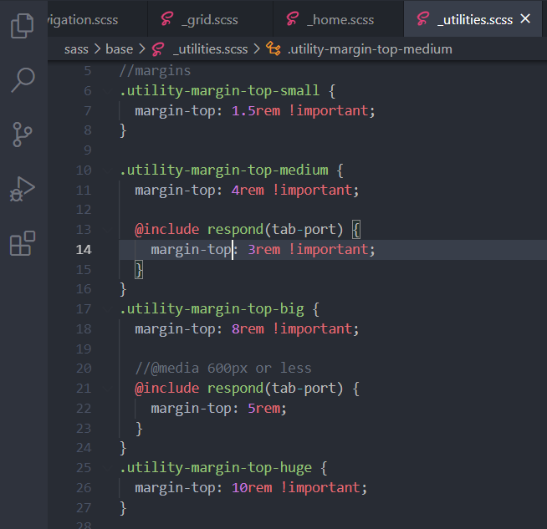

Remember to add media queries to your utilities and possibly variables, where they are assigned or define properties that define box sizes, like margin, padding and height and widths

## Writing media queries to change the card section

Note that on mobile and tablet devices there is no such thing as hover. We must take this into consideration, so that our animations on hover either perform on click, or elements that become visible only on hover, should perhaps be rethought and redesigned so that they are visible always, as mobile users are not used to expecting new things to become visible on a website only after they click it. On mobile common and good practice is content is priority, and easy content even more so. So everything should be on screen and at face value as much as possible.

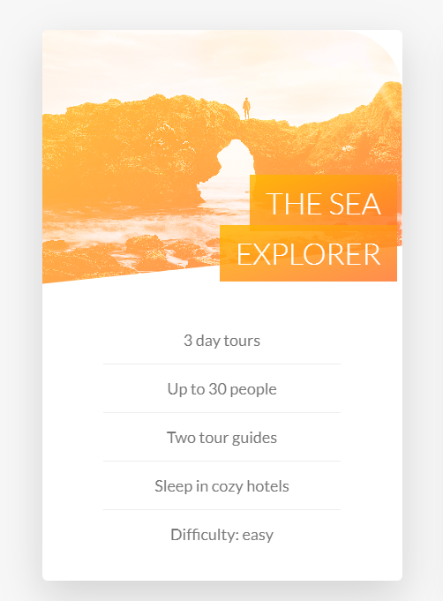

Above we can see on the right how it currently looks, and on the left how we want it to look. (ignore the huge play button overlay).

For making this huge change (media query re-write) we will not be inserting media queries into individual nested or un-nested elements as we normally do with small and subtle tweaks, but will instead write a large media query at the bottom of our component file (__card.scss in this case) copy the entire component code above, into that query, and modify the code in the query (re-writing/deleting what we don’t need).

## Difference between background-size:100% vs background-size:cover;

In a nutshell, background-size:100%; makes sure that the image takes up the entire horizontal space of the container.

While background-size:cover; makes sure that the image takes up the entire vertical space of the container.

What this means Is that:

* We should use **bacground-size:cover;** if we have containers that are more vertical than horizontal, (in other words, use it for vertical column like containers).
* And we should use **background-size:100%;** to stretch our image over horizontal container block (row like containers)



Image covers the vertical space of the container by having the background-size: cover; (Yplane). This is the container implementing a media query to make it display well on mobile devices, so the media query applies some changes from the already set **background-size** porperty value, which was set to 100%.

We can see that the **cover** makes the image scale up as much as necessary to make its entire vertical plane fit into the container, allowing parts of the horizontal plane to be cropped

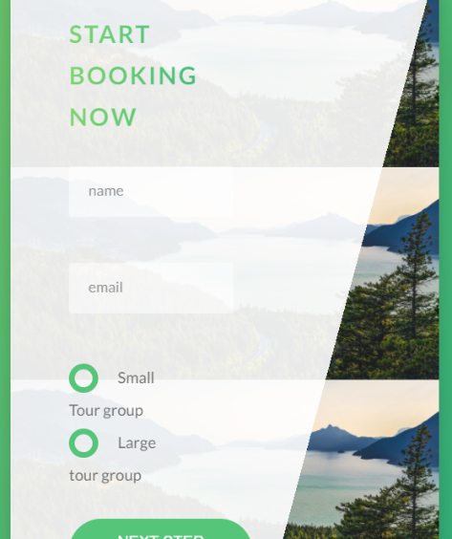Now let’s see what a vertical container looks like, when background-size is still set uto 100%

Basically the image tries to maintain it’s aspect ratio in order to fit entirely on the horizontal plane(seeing as how 100% or cover, does not allow the image to morph(loose it’s aspect ratio) the image cannot vertically stretch, so it replicates itself on the vertical plane three times in order to fully appear on the horizontal plane.

This happens because in order to make the entire horizontal plane of the image fit into the container, the image needs to be scaled down so much, that it becomes so small, the only way for it to fill the vertical space is to either repeat or stretch (which background size does not support)

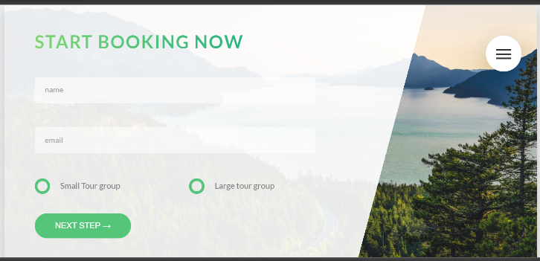The same image from above using the background-size:100%; Here we can see that it totally works, and the image still maintains it’s aspect ratio. In conclusion this works excellently for horizontal content blocks.

## Responsive images

The goal of responsive images is to serve the **right image** to the **right screen size** and device, in order to avoiud downloading unnecessary large images on smaller screens.

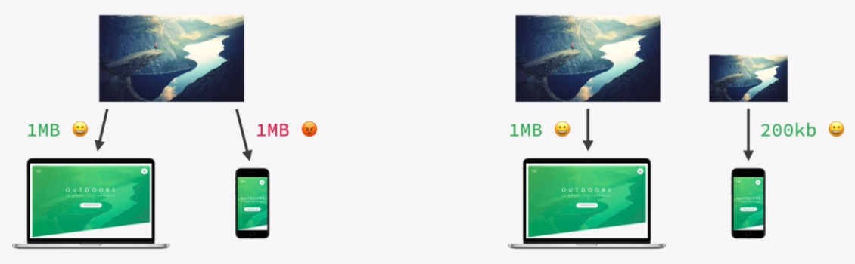

### **When to use responsive images (THE THREE CASES)**

#### **1.Resolution switching (screen size smaller vs larger)**

When we want our images to display properly on screens that are of different sizes. The same image will not display identically if it takes up 100% of a screen, on a phone and on a desktop.

#### **2. Density switching (low res screens vs high res screens)**

Resolution-density represents the density (amount) of pixels on an area of the screen. A screen that is more resolution dense will have more pixels per inch, then the one that is less resolution dense.

**Low resolution density** is usually our average desktop display(as it is usually viewed from a distance) and represents 1*1 pixel to pixel ratio. (1px unit for these screens translates to an exact real 1px on the actual screen.

**High resolution density** is what we see on modern smartphones, because these screens are usually viewed from a nearer distance, closer to the eye, and the pixel ratio of these devices is usually 2-1. 1px unit, specified for the browser, actually translates to two real world pixels on a high resolution density screen. This process is done automatically, so don’t worry, you won’t have to do a pixel conversion for high resolution devices.

#### **3.Art directon switching**

Art direction happens when you don’t want to serve the same image on a different screen, but you may choose to use a completely different image, or image component

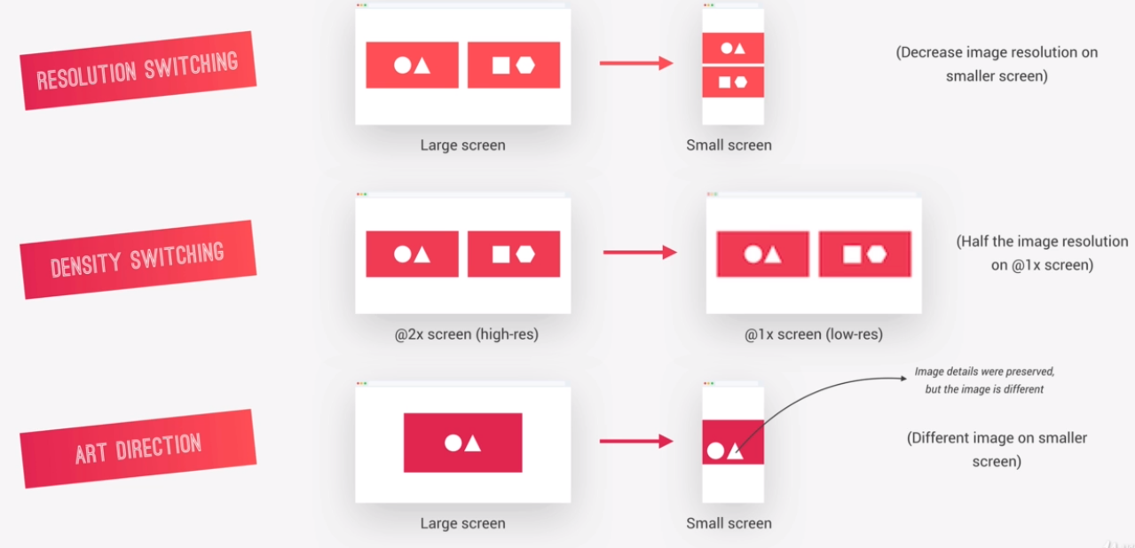

## Responsive images in HTML

## **Implementing density switching**

### Srcset (source-set) attribute

Allows us to place more than a single image link inside the source (now srcset/a set of sources) attribute, adding to each link a **density descriptor** which tells the browser at which resolution density what picture should be used.

The following code shows how it should be used for normal 1x density(desktop 1px is 1px) and for high 2x density (mobile 1px is 2px), applying next to the images **1x** or **2x** respectively.

When choosing the image for one or the other density, remember the 1:2 rule, which means that if one resolution is okay for your low density screen, you need twice the resolution(twice as many pixels) for the high density screen 1080px 1x 2160px 2x, and so on… (Keep this in mind when downloading pictures and choosing picture sizes, make sure the resolution scales 1:1 🡪 1x and 1:2 🡪2x

<img srcset="images/logo-green-2x.png 2x, images/logo-green-1x.png 1x" alt="Full logo" class="footer__logo" />

## Implementing art direction switching

**<footer class="footer">**

**<div class="footer__logo-box">**

**<picture class="footer__logo">**

**<source srcset="images/logo-green-2x.png 2x, images/logo-green-1x.png 1x" media="(max-width:37.5em)" />**

**<img srcset="images/logo-green-2x.png 2x, images/logo-green-1x.png 1x" alt="Full logo" class="footer__logo" />**

**</picture>**

**</div>**

We start off by using the <picture> element in which we can specify multiple sources for the same image that will display via the parent <picture> element. (The picture element is basically a nested multiple tag version of the normal img self closing element, where In the picture element, the image source is not an attribute, but a whole new tag nested within it.

In the **srcset** attribute of the <source> tag, we can actually set a media query using the keyword **media="(max-width:37.5em)"** for example, where we define at which breakpoints we wish our different sources to apply. So each time we create a new **source tag** within the **picture element**, we may give it a different value for the **media**  attribute, and once a viewport width that corresponds to the min/max width of the media query is used, the browser is forced by said media query to use its specific source-set as the primary source for the image, displayed via parent picture tag.

For displaying the defaul image that requires no media query breakpoint, we simply add an <img> tag.

**Note how inside our <source> and <img> elements** used for **Art-direction** we are also implementing density switching, as both can and should be used together, That is why our <source> and <img> tags are not using the src attribute but a **srcset(**source-set) attribute to define the appropriate image relative to it’s 1x / 2x pixel resolution density.

### Adding an aditional **src** attribute for browsers not supporting **srcset**

<div class="footer__logo-box">

        <!--Art design and pixel-density scaling-->

        <picture class="footer__logo">

          <source srcset="images/logo-green-2x.png 2x, images/logo-green-1x.png 1x"

          media="(max-width:37.5em)"

          />

          <img

            srcset="images/logo-green-2x.png 2x, images/logo-green-1x.png 1x"

            src="images/logo-green-2x.png 2x"

            alt="Full logo"

            class="footer__logo"

          />

        </picture>

      </div>

Rememebering that not all browsers actually do support Art-design and/or denisity/resolution image scaling, we should make sure to add an additional **src** attribute, so that our default pictures still display in the older browsers.

Note that this **src** attribute will get ignored in the modern browser since **srcset** has precedance(priority) over the standard src attribute. So don’t worry about modern broswers not loading all your hard work implementing responsive images, just remember to add the backup **src** attribute to the **srcset** one (if your are using it), in your <img> tag.

## **Resolution switching**

Scaling the image based on device/viewport/ width. So for phones for example, we would load an image of 300px in width, while for desktops we would have an alternative image 1140px wide.

<img

         srset="images/nat-1-large.jpg **300w**, images/nat-1.jpg **1000w**"

**sizes**="(**max-width**: 900px) **17vw**, (**max-width**:600px) **25vw**, **300px**"

         alt="Photo 1"

         class="composition__photo composition__photo--p1"

         src="images/nat-1-large.jpg"

/>

Basically what we do here, is define two images in a **srcset** in which we pass directory paths/relative paths to our differently scaled images, and for each image we define a **resolution descriptor (300w** for an image that has a native 300px width or **1000w** for an image that we download in a 1000px resolution). In this **resolution descriptor**  we define to the browser how wide image file is. For the adjacent specified relative/absolute image path. srset="images/nat-1-large.jpg **300w**, images/nat-1.jpg **1000w**"

**To get the information for the resolution descriptor, simply check the image resolution for the image file you are atempting to use, in your image directory**

Apart from the image descriptor, we also have to define the **sizes** attribute. This attribute basically accepts key value pairs as follows: **(breakpoint: x) imgWidth@reakpoint% Xvw(viewport width%)**

To calculate the image width at the breakpoint (and breakpoints are usually chosen to be the same breakpoints we’ve defined in our @mediaQuery manager) we do the following.

1. Go to the developer tools, scale the viewport to the defined breakpoint width
2. On that breakpoint width (**max-width**: 900px for example) inspect our img element, and read the first number in the element size description: **1523x 101.28** (first one is the width:1523, second the height)
3. We divide current device width at the breakpoint resolution with the breakpont resolution 1523/900=17
4. The result of the division is the viewport-width(vh) percentage, and this is the value that we pass **sizes="(max-width: 900px) 17vw.** So 17vw represents 17% of viewport width at the breakpoint of 900px. **Do this for each media query breakpoint you are using and you are done.**

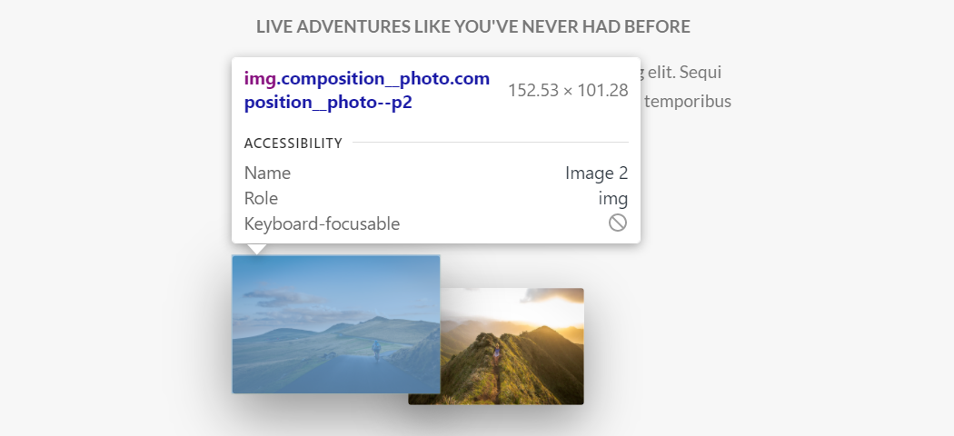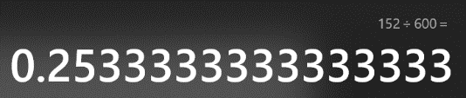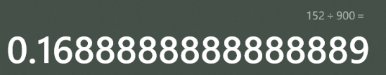

**What it looks like in our html code**

<div class="column-1-of-2">

            <div class="composition">

              <!--Implementing Image resolution scaling-->

              <img

                srset="images/nat-1-large.jpg 300w, images/nat-1.jpg 1000w"

                sizes="(max-width: 900px) 17vw, (max-width:600px) 25vw, 300px"

                alt="Photo 1"

                class="composition__photo composition__photo--p1"

                src="images/nat-1-large.jpg"

              />

              <img

                srset="images/nat-2-large.jpg 300w, images/nat-2.jpg 1000w"

                sizes="(max-width: 900px) 17vw, (max-width:600px) 25vw, 300px"

                alt="Photo 2"

                class="composition__photo composition__photo--p2"

                src="images/nat-2-large.jpg"

              />

              <img

                srset="images/nat-3-large.jpg 300w, images/nat-3.jpg 1000w"

                sizes="(max-width: 900px) 17vw, (max-width:600px) 25vw, 300px"

                alt="Photo 3"

                class="composition__photo composition__photo--p3"

                src="images/nat-3-large.jpg"

              />

            </div>

## Responsive images in CSS

Responsive images are pretty straightforward as far as implementing them in css is concered. What we are doing is basically writing media queries., Now instead of using min/max-width referencing the screen (viewport) size. When creating media queries for making responsive images in css, we will be using **min/max-resolution** and with that our **high resolution reference** will be **192dpi** (dpi-dots per inch). Why 192**dpi**? Well, because that is the resolution for Apple retina-screen, and that resolution is used as a high resolution screen reference.

.header {

  position: relative;

  /*keep the element height always at 95% of the viewport height*/

  height: 95vh; /*95vh --> 95%vieport-height*/

  background-image:

linear-gradient(*to* right bottom,

rgba($color-primary-light, 0.8),

rgba($color-primary- dark, 0.8)), url(*../images/hero-small.jpg*);

  //responsive-backgroundImage

  //we want our high-resolution image to be loaded on a high resolution screen

  @media (min-resolution: 192dpi) and (min-width: 600px), (min-width: 2000px) {

 background-image:

linear-gradient(*to* right bottom,

rgba(powderblue, 0.8),

rgba(powderblue, 0.8)),

url(*../images/hero.jpg*);

  }

Basically in the code above we see the implementation of a high resolution iimage in the case that the screen has a high pixel density (192dpi) and belongs to a device that is not a smartphone(min-width: 600px).

Alternatively it checks if the current viewport display is larger than 2000px(very large screen) in which case, even if the pixel density is low, we still want our high-res image to display

How these media query rules apply is as follows (AND is literaly writen as (**and**) while OR is written as **(,)** a comma

**@media (min-resolution 192dpi) AND (min-width:600px) OR (min-width:2000px)**

**{ apply the following styles 🡪 @content}**

is written in CSS as:

@media (min-resolution: 192dpi) and (min-width: 600px), (min-width: 2000px)

*{ apply the following styles 🡪 @content}*

### **Remembering to convert our px units to em units for media queries**

@media (min-resolution: 192dpi) and (min-width: 600px), (min-width: 2000px)

*{ apply the following styles 🡪 @content}*

So first we have 600px. Knowing that an **em** in a media query, just like a **rem** is 16px, we will get our relative equivealent of **em** by implementing the simple following conversion: **(n)px/16 = (m)em**

**Converting px breakpoints to em**:

600px/16 = 37.5em;

2000px/16 = 125em;

Now we can insert our relative units for the media query breakpoints

@media (min-resolution: 192dpi) and (min-width: **37.5em**), (min-width:**125em**)

*{ apply the following styles 🡪 @content}*

## **backdrop-filter vs filter**

Backdrop filter is the latest css technology as of 2017, and what it does is apply a style, blur, hue, saturation, to the element behind the current element, or behind the element of the current selector.

So while the filter property makes changes to the overlay of the current element, the **backdrop-filter** makes changes to the element positioned behind the currently selected element. So it basically globally changes all elements that are positioned behind or have as lesser z-index than the element we are adding a backdrop-filter to.

This is really handy if we want to apply a bunch of styles to all of the elements positioned behind an element, without ever having to write selectors and add multiple individual rules to those elements.

## Testing for Browser Support with @support

Always check [Can I use... Support tables for HTML5, CSS3, etc](https://caniuse.com/) to check if your new implemented features are supported on the browsers which you want your website to properly display on

### **Concept of “graceful degradation”**

This concept basically entails us setting new alternative styles for browsers that cannot implement the latest in css or html technologies. So instead of having an top-notch element style simply fail to work in an older browser version, it will through an additional, simpler style we’ve implemented, gracefully degrade into another version of the element, supported by the older browsers.

.popup {

  position: fixed;

  top: 0;

  left: 0;

  height: 100vh;

  width: 100vw;

  background-color: rgba($color-black, 0.8);

  z-index: 5000;

  //Making the element hidden before it pops up

  opacity: 0;

  visibility: hidden;

  //Animating the popup

  transition: all 0.5s;

  //Adding on optional style if it is browser supported

  @supports (-webkit-backdrop-filter: blur(10px)) or (orbackdrop-filter: blur(20px)) {

    //Backdrop filter does not work in chrome(but only on safary)

    -webkit-backdrop-filter: blur(10px);

    backdrop-filter: blur(20px);

    background-color: rgba($color-black, 0.3);

  }

What the @supports query does is practically test if the properties passed as arguments inside the parameter brackets, are supported by the browser that is currently loading the page.

If the argument list is **true** (supported) then the declaration block inside the **@supports** query get executed. If the argument list is **false**(the passed arguments are not supported by the current browser) then the declaration block inside the **@supports** query gets ignored.

  @supports (-webkit-backdrop-filter: blur(10px)) or (orbackdrop-filter: blur(20px)

In the code above, if either prefixed or non prefixed version of the backdrop-filter property is supported the declaration block will get executed. **This represents the implementation of graceful degradation**

## **Creating graceful degradation for Safari(i-phone)**

Since most people using Iphones (a lot of people, to put it lightly) use safari, we have to make sure our website displays properly on the safari browser as well.

Safari does not recognize **min-resolution** so the min-resolution: 192dpi equivalent for safari would be (-webkit-min-device-pixel-ratio: 2) where the ratio represents a high resolution retina screen, or as we remember from the pixel density lesson, the 2x pixel density.

So in our media query below, we are basically stating the following execution condition:

* **The** minimum resolution is 192dpi **AND** the width is larger than a phone **OR** the device has a very large screen, regardless of pixel density,
* **OR**
* (safari): the device pixel ratio is 2x) **AND** the width is larger than a phone (min-width:37.5em) **OR** the device has a very large screen(125em) regardless of pixel density
* apply the following styles:

This means that either the standard browser or safari media query has to be true for the styles to get applied.

So one of the statements between the **OR** separating the standard browser condition and safari browser condition has to be **TRUE** for the styles to apply.

//responsive-backgroundImage

  //we want our high-resolution image to be loaded on a high resolution screen

  @media (min-resolution: 192dpi) and (min-width: 37.5em),

    (min-width: 125em),

    (-webkit-min-device-pixel-ratio: 2) and (min-width: 37.5em),

    (min-width: 125em) {

    background-image: linear-gradient(*to* right bottom, rgba($color-primary-light, 0.8), rgba($colorprimary-dark, 0.8)), url(*../images/hero.jpg*);

  }

## Applying graceful degradation when **clip-path** is not supported

Basically, we’ll be using a feature-query @supports, to define to the browser to only use clip path if the property is supported, and to otherwise ignore it completely.

.header {

  position: relative;

  /*keep the element height always at 95% of the viewport height*/

  height: 85vh; /*95vh --> 95%vieport-height*/

  background-image: linear-gradient(*to* right bottom, rgba($color-primary-light, 0.8), rgba($color-primary-dark, 0.8)), url(*../images/hero-small.jpg*);

  background-size: cover; /*fits the element inside the full parent box*/

  background-position: top; /*makes sure the top of the image stays at the top of the viewport*/

  // FEATURE-Query that applies clip-path only to those browsers that support it

  //Note that as an argument, clip path can have any value inserted into it, just as long

  //as the values for the clip path are not empty, so that the browser recognizes it

  @supports (clip-path: polygon(0 0)) or (-webkit-clip-path: polygon(0 0)) {

    -webkit-clip-path: polygon(0 0, 100% 0, 100% 75vh, 0 100%);

    clip-path: polygon(0 0, 100% 0, 100% 75vh, 0 100%);

    height: 95vh; /*95vh --> 95%vieport-height*/

    //Creates a longer element to loook more aesthetic with the clip path

  }

## **Setting up a simple Build Process with NPM scripts**

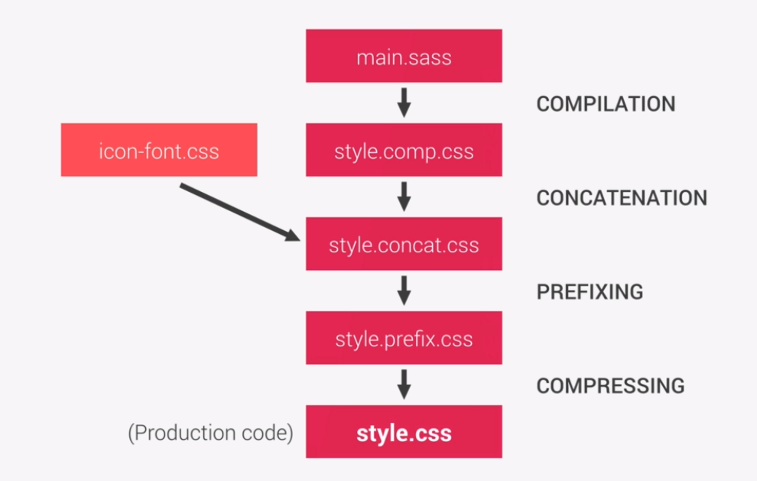

Basically a build process is a process that compiles our workiing sass and css files into a single css file, so that our website is ready to get immediately deployed on a server.

### **Step 1 and 2 (Compile and Concatinate)**

"scripts": {

    "watch:sass": "node-sass sass/main.scss css/style.css -w",//displays watches for changes -w

    "compile:sass": "node-sass sass/main.scss css/style.comp.css" //compiles into final build

"concat:css": "concat -o css/style.concat.css css/icon-font.css style.comp.css ./3.css"

  },

"node-sass sass/main.scss css/style.comp.css" 🡪 this task compiles all the sass files into a new style.comp.css file. Comp stands for compile. Also key value pairs inside a json file are called tasks.

"concat:css": "concat -o css/style.concat.css css/icon-font.css style.comp.css"

What this does is it concatinates css files into a single css file, called style.concat.css

So the icon-font.css and the style.comp.css file from our previous task are getting concatinated into a single css file.

For this action to work we’ve had to instal a new npm package in our project folder using the command prompt.

**npm instal concat -–save-dev** (saved as a developer dependency –-save-dev), and we’ve googled “npm concat” to see how to use this package to concatinate our css files.

### **So lets now look at our build process steps**

1.Compile all SASS files into a single css file.

2.Compile all css files into a single css file.

3.Apply an automatic prefixer for all prototype css properties

4. Compressing

### **Step 3.**

Allowing prefix-ing, or placing the –moz-, -webkit- etc, on the latest css technologies

For this we will need two more npm packages installed in our project directory(>cd ProjectDirectory) from our command prompt

And they are:

**npm install autoprefixer -–save-dev**

**npm i -D postcss postcss-cli-–save-dev**

Autoprefixer is actually a part of the postcss plugin.package

### **How to write a script for and run the autoprefixer:**

 "prefix:css": "postcss --use autoprefixer **-b 'last 10 versions' css/style.concat.css -o css/style.prefix.css**"

**--use -b'last 10 versions' css/style.concat.css -o css/style.prefix.css**"

Note that here we are accessing the –use option to get the autoprefixer component from our postcss-cli package.

* **“- b ‘Last 10 versions’ ”** 🡪 -b option stands for (browsers) and it tells the script to implement auto-prefixing of prototype css properties for the latest 10 versions (it will keep up to date)
* **“css/style.concat.css”** 🡪 represents the input file, that the autoprefixer takes and applies prefixes to
* **“-o css/style.prefix.css”** 🡪(-o option stands for output) and it represents the output file, that the autoprefixer will create and store the finished (prefixed) css

**Running the autoprefixer**

**>npm run prefix:css**

### **Step 4 Compressing**

"compress:css": "node-sass css/style.prefix.css css/style.css --output-style compressed",

This process requires no additional npm packages, so we simply envoke the **node-sass** package, give it the input file (the final file from step 3 prefixing) **css/style.prefix.css** and then the name of our desired file, which in this case is going to be a simple non-descript **css/style.css**

### **Last step “build:css” (Joining all 4 steps into a single task/script)**

For the last step, we want all of our four steps to be able to happen by envoking a single task in our command prompt, instead of always envoking all four steps incrementally one by one.

The script/task that executes all four build-tasks will be called **“build:css”** remembering that all this naming is optional (you can call your tasks whatever you want, though it is better to follow a common naming convention)

For this we need a **run-all** command, that we get from another **npm-package**

#### **Instaling the “npm-run-all” package**

**>npm install npm-run-all –-save-dev**

Then we write the script calling the “run-all” command

 "build:css": "npm-run-all compile:sass concat:css prefix:css compress:css"

In the npm-run-all command we basically pass it all the task names from our previous steps:

"compile:sass": "node-sass sass/main.scss css/style.comp.css",

    "concat:css": "concat -o css/style.concat.css css/icon-font.css css/style.comp.css",

    "prefix:css": "postcss --use autoprefixer -b 'last 10 versions' css/style.concat.css -o css/style.prefix.css",

    "compress:css":

forwarding these tasks so that the **build:css** command has the ability to on its own, call and execute all four steps for us, whenever we run "build:css in the command prompt.

#### **Executing all four steps with a single command**

**>npm run build:css**

## Setting up the development process so that we can run (liveserver and compile:sass at the same time)

Remember that our development process has two components

1. Compiling our written SASS code into a single css file
2. Running a live-server that runs the compiled css file so that we can watch our changes

So in essence, this process enables us to watch our development progress before we’ve built our project, ready to get deployed.

In this sense, we can create an even more developer friendly environment if we run our compile:sass task, and the live-server task, with a single command

For this we will use the same principle we used to connect all the commands for our build process into one command that executes all of our 4 steps

    "watch:sass": "node-sass sass/main.scss css/style.css -w",

    "devserver": "live-server",

    "start": "npm-run-all --parallel devserver watch:sass ",

First we create two tasks:

* watch:sass 🡪 to compile our sass files into a single css file
* And a “devserver” 🡪 Which runs the live-server option from the npm package

Then we create a new task “start” using the npm-run-all command from the npm run-all package, where we choose the option for the run-all command, where it runs the passed tasks in **–parallel**, before passing it the tasks we want it to run: **watch:sass devserver**

Now to setup our development environment we simply need to open an npm enabled command prompt and run

**>npm run start**

# Build and development process (package.json file)

Copy the scripts and dependencies into your current project **package.json** file

Remember that .json files do not allow comments, so remember not to paste those

{

  "name": "natours",

  "version": "1.0.0",

  "description": "Landing page for natours",

  "main": "index.js",

//Copy all the scripts for running the process in your current project

  "scripts": {

    "watch:sass": "node-sass sass/main.scss css/style.css -w",

    "devserver": "live-server",

    "start": "npm-run-all --parallel devserver watch:sass ",

    "compile:sass": "node-sass sass/main.scss css/style.comp.css",

    "concat:css": "concat -o css/style.concat.css css/icon-font.css css/style.comp.css",

    "prefix:css": "postcss --use autoprefixer -b 'last 10 versions' css/style.concat.css -o css/style.prefix.css",

    "compress:css": "node-sass css/style.prefix.css css/style.css --output-style compressed",

    "build:css": "npm-run-all compile:sass concat:css prefix:css compress:css"

  },

  "author": "Adam",

  "license": "ISC",

//Copy all of the dev-dependencies (installed packages so the process tasks work)

  "devDependencies": {

    "autoprefixer": "^10.2.1",

    "concat": "^1.0.3",

    "node-sass": "^5.0.0",

    "npm-run-all": "^4.1.5",

    "postcss": "^8.2.4",

    "postcss-cli": "^8.3.1"

  },

  "dependencies": {

    "install": "^0.13.0",

    "live-server": "^1.2.1"

  }

}